**RaiseUp: A Habit Tracking Mastery App**

A PROJECT REPORT

#### Submitted by

A.J SAMUVEL [RA2211026010131]

JENISH R [RA2211026010132]

DUVVURU NIVRUTH [RA2211026010160]

#### Under the Guidance of

## Dr. KRISHNAVENI S

Associate Professor

Department of Computational Intelligence

### *in partial fulfillment of the requirements for the degree of*

## BACHELOR OF TECHNOLOGY

## in

## COMPUTER SCIENCE ENGINEERING

## with specialization in Artificial Intelligence And Machine Learning



## DEPARTMENT OF COMPUTATIONAL INTELLIGENCE COLLEGE OF ENGINEERING AND TECHNOLOGY

SRM INSTITUTE OF SCIENCE AND TECHNOLOGY

## KATTANKULATHUR- 603 203

### APRIL 2025

### Logo Department of Computational Intelligence

### **SRM Institute of Science & Technology**

##### Own Work* Declaration Form

##### Degree/ Course : B.Tech (CSE AIML)

**Student Name : A J Samuvel, Jenish R, Duvvuru Nivruth**

##### Registration Number : RA2211026010131, RA2211026010132,

##### RA2211026010160

**Title of Work : RaiseUp: A Habit Tracker Mastery App**

We hereby certify that this assessment compiles with the University’s Rules and Regulations relating to Academic misconduct and plagiarism**, as listed in the University Website, Regulations, and the Education Committee guidelines.

We confirm that all the work contained in this assessment is our own except where indicated, and that we have met the following conditions:

* Clearly referenced / listed all sources as appropriate
* Referenced and put in inverted commas all quoted text (from books, web, etc)
* Given the sources of all pictures, data etc. that are not my own
* Not made any use of the report(s) or essay(s) of any other student(s) either past or present
* Acknowledged in appropriate places any help that we have received from others (e.g. fellow students, technicians, statisticians, external sources)
* Compiled with any other plagiarism criteria specified in the Course handbook / University website

We understand that any false claim for this work will be penalized in accordance with the University policies and regulations.

|  |
| --- |
| **DECLARATION:** |
| We are aware of and understand the University’s policy on Academic misconduct and plagiarism and we certify that this assessment is our own work, except where indicated by referring, and that we have followed the good academic practices noted above. |
| RA221102601011 RA2211026010132 RA2211026010160 |

# Logo

# SRM INSTITUTE OF SCIENCE AND TECHNOLOGY KATTANKULATHUR – 603 203

## BONAFIDE CERTIFICATE

Certified that 21CSP303J – Software Engineering and Project Management report titled “**RaiseUp: A Habit Tracker Mastery App**” is the bonafide work of **“A.J Samuvel [RA2211026010131], Jenish R [RA2211026010132], Duvvuru Nivruth [RA2211026010160]”** who carried out the project work under my supervision. Certified further, that to the best of my knowledge the work reported herein does not form any other project report or dissertation on the basis of which a degree or award was conferred on an earlier occasion on this or any other candidate.

|  |  |
| --- | --- |
| **SIGNATURE**  Dr. Krishnaveni S  **Supervisor**  Associate Professor  Department of Computational Intelligence  SRM Institute of Science and Technology  Kattankulathur | **SIGNATURE**  Dr. R.Annie Uthra  **Head of the Department**  Professor  Department of Computational Intelligence  SRM Institute of Science and Technology Kattankulathur |

**ACKNOWLEDGEMENTS**

We express our humble gratitude to **Dr. C. Muthamizhchelvan**, Vice-Chancellor, SRM Institute of Science and Technology, for the facilities extended for the project work and his continued support.

We extend our sincere thanks to **Dr. Leenus Jesu Martin M,** Dean-CET, SRM Institute of Science and Technology, for his invaluable support.

We wish to thank **Dr. Revathi Venkataraman**, Professor and Chairperson, School of Computing, SRM Institute of Science and Technology, for her support throughout the project work.

We encompass our sincere thanks to, **Dr. M. Pushpalatha**, Professor and Associate Chairperson - CS, School of Computing and **Dr. Lakshmi,** Professor and Associate Chairperson -AI, School of Computing, SRM Institute of Science and Technology, for their invaluable support.

We are incredibly grateful to our Head of the Department, Dr. R.Annie Uthra, Computational Intelligence, SRM Institute of Science and Technology, for her suggestions and encouragement at all the stages of the project work.

We want to convey our thanks to our Project Coordinators, Panel Head, and Panel Members Department of Computational Intelligence, SRM Institute of Science and Technology, for their inputs during the project reviews and support.

We register our immeasurable thanks to our Faculty Advisor, Dr.Prithi S, Department of Computational Intelligenc, SRM Institute of Science and Technology, for leading and helping us to complete our course.

Our inexpressible respect and thanks to our guide, Dr.Krishnaveni S, Department of Computational Intelligence, SRM Institute of Science and Technology, for providing us with an opportunity to pursue our project under her mentorship. She provided us with the freedom and support to explore the research topics of our interest. Her passion for solving problems and making a difference in the world has always been inspiring.

We sincerely thank all the staff members of Computational Intelligence, School of Computing, S.R.M Institute of Science and Technology, for their help during our project. Finally, we would like to thank our parents, family members, and friends for their unconditional love, constant support and encouragement

A J Samuvel,

Jenish R,  
Duvvuru Nivruth

### **ABSTRACT**

This project presents the development of "Raise Up," a challenge tracking application designed to help users set and achieve personal goals through a simple yet effective interface. Built using Python for the backend and HTML/CSS with minimal JavaScript for the frontend, the application provides a straightforward solution for personal development tracking.The core functionality of Raise Up focuses on challenge creation and progress monitoring, allowing users to set personal goals and track their completion. The application features a clean, user-friendly interface that emphasizes ease of use and clear visualization of progress. Users can create challenges, mark them as complete, and view their achievement history.

The core functionality of Raise Up focuses on challenge creation and progress monitoring, allowing users to set personal goals and track their completion. The application features a clean, user-friendly interface that emphasizes ease of use and clear visualization of progress. Users can create challenges, mark them as complete, and view their achievement history.

**TABLE OF CONTENTS**

|  |  |  |  |  |
| --- | --- | --- | --- | --- |
| **ABSTRACT** | | **v** | | |
| **TABLE OF CONTENTS** | | **vi** | | |
| **LIST OF FIGURES** | | **viii** | | |
| **LIST OF TABLES** | | **x** | | |
| **ABBREVIATIONS** | | **xi** | | |
| **CHAPTER NO.** | **TITLE** | | | **PAGE NO.** |
| **1** | **INTRODUCTION** | | | **1** |
| 1.1 | Introduction to Project | | | 1 |
| 1.2 | Motivation | | | 1 |
| 1.3 | Sustainable Development Goal of the Project | | | 1 |
| 1.4 | Product Vision Statement | | | 2 |
| 1.5 | Product Goal | | | 3 |
| 1.6 | Product Backlog | | | 4 |
| 1.7 | Product Release Plan | | | 5 |
| **2** | **SPRINT PLANNING AND EXECUTION** | | | **6** |
| **2.1** | **Sprint 1** | | | **6** |
| 2.1.1 | Sprint Goal with User Stories of Sprint 1 | | | 6 |
| 2.1.2 | Functional Document | | | 9 |
| 2.1.3 | Architecture Document | | | 11 |
| 2.1.4 | UI Design | | | 14 |
| 2.1.5 | Functional Test Cases | | | 15 |
| 2.1.6 | Sprint Retrospective | | | 15 |
| **2.2** | **Sprint 2** | | | **16** |
| 2.2.1 | Sprint Goal with User Stories of Sprint 2 | | | 16 |
| 2.2.2 | Functional Document | | | 19 |
| 2.2.3 | Architecture Document | | | 21 |
| 2.2.4 | UI Design | | | 24 |
| 2.2.5 | Functional Test Cases | | | 25 |
| 2.2.6 | Sprint Retrospective | | | 25 |
| **3** | **RESULTS AND DISCUSSIONS** | | | **26** |
| 3.1 | Project Outcomes | | | 26 |
| 3.2 | Committed vs Completed User Stories | | | 29 |
| **4** | **CONCLUSIONS & FUTURE ENHANCEMENT** | | | **30** |
| **APPENDIX** | | | **31** | |
| **A. SAMPLE CODING** | | | **31** | |

**LIST OF FIGURES**

|  |  |  |
| --- | --- | --- |
| **CHAPTER NO** | **TITLE** | **PAGE NO.** |
| 1.1 | MS Planner Board of RaiseUp | 5 |
| 1.2 | Release plan of RaiseUp | 5 |
| 2.1.1 | Building User registeration page | 7 |
| 2.1.2 | Building the Logic of the gamification system | 8 |
| 2.1.3 | System Architecture Diagram | 12 |
| 2.1.4 | Sequence Diagram | 13 |
| 2.1.5 | UI Design of Login Page | 14 |
| 2.1.6 | UI Design of Register Page | 14 |
| 2.1.7 | Functional Test Cases for the Sprint 1 | 15 |
| 2.1.8 | Sprint Retrospective for the Sprint 1 | 15 |
| 2.2.1 | Implementation of Leaderboards | 17 |
| 2.2.2 | Implementation of Offline System | 18 |
| 2.2.3 | Data Flow Diagram | 22 |
| 2.2.4 | Use Case Diagram | 23 |
| 2.2.5 | UI displays the leaderboards of fellow people | 24 |
| 2.2.6 | UI displays all the habits that are created, offline mode | 24 |
| 2.2.7 | Functional Test Cases for the Sprint 2 | 25 |
| 2.2.8 | Sprint Retrospective for the Sprint 2 | 25 |
| 3.1 | Sign up Page | 26 |
| 3.2 | Login Page | 26 |
| 3.3 | User Dashboard | 27 |
| 3.4 | User can add challenges / Pre-requisites too | 27 |
| 3.5 | Leaderboards Page | 28 |
| 3.6 | Settings Page | 28 |

**LIST OF TABLES**

|  |  |  |
| --- | --- | --- |
| **CHAPTER NO** | **TITLE** | **PAGE NO.** |
| 1.1 | Product Backlog | 4 |
| 2.1.1 | Detailed User Stories of Sprint 1 | 6 |
| 2.1.2 | Access level Authorization Matrix for Sprint 1 | 10 |
| 2.2.1 | Detailed User Stories of Sprint 2 | 16 |
| 2.2.2 | Access level Authorization Matrix for Sprint 2 | 21 |

**ABBREVIATIONS**

|  |  |
| --- | --- |
| UI | User Interface |
| UX | User Experience |
| HTML | Hypertext Markup Language |
| CSS | Cascading Style Sheets |
| JS | Java Script |
| DB | Database |
| US | User Story |
| API | Application Programming Interface |
| PWD | Password |
| AUTH | Authentication |
| DEV | Development |
| PROD | Production |
| TEST | Testing Environment |
| XP | Experience |
| ID | Identifier |
| MVP | Minimum Viable Product |

**CHAPTER 1**

**INTRODUCTION**

**1.1 Introduction to Project:**

In today's fast-paced world, maintaining motivation and tracking personal progress towards goals can be challenging. Many individuals struggle with consistency and accountability when working towards personal development objectives. This project, "Raise Up," addresses these challenges by providing a simple yet effective solution for tracking personal challenges and achievements. The motivation behind Raise Up stems from the need for a straightforward tool that helps users maintain focus on their goals without unnecessary complexity.

**1.2 Motivation**

As someone who has struggled with maintaining consistency in personal goals and challenges, I found myself searching for a simple, effective way to track my progress. Existing productivity apps often felt overwhelming with their complex features and cluttered interfaces, making it harder to focus on what really mattered - actually completing my goals. .

**1.3 Sustainable Development Goal of the Project**

Raise Up aligns cwith the United Nations Sustainable Development Goal 4: Quality Education, specifically target 4.4 which aims to "substantially increase the number of youth and adults who have relevant skills, including technical and vocational skills, for employment, decent jobs and entrepreneurship." While Raise Up is not directly an educational platform, it supports lifelong learning and personal development by providing individuals with a tool to track and maintain their skill development and personal growth goals. The application's focus on consistency and progress tracking helps users develop important life skills such as time management, goal setting, and self-discipline. By making personal development more accessible and trackable, Raise Up contributes to creating a culture of continuous learning and self-improvement, which are essential components of sustainable development.

**1.4 Product Vision Statement**

1.4.1. Audience:

* Primary Audience: Individuals looking to build and maintain consistent habits, People struggle with motivation and need structured progress tracking, Users who prefer a gamified approach to habit-building with milestones and rewards.
* Secondary Audience: Productivity enthusiasts looking for an intuitive way to track habits, Coaches and mentors who want to monitor and support others’ habit progress.

1.4.2. Needs:

Primary Needs:

* A structured habit tracker with milestone-based progression.
* Visual indicators (⭐ Milestones, 🔥 Streaks, 🔒 Locked Activities) to encourage consistency.

Secondary Needs:

* Insights and analytics on habit trends and progress.
* Social or accountability features to keep users motivated.

1.4.3. Products:

* Core Product: A web-based habit mastery tracker that helps users build consistent habits through gamification, milestone-based rewards, and streak tracking. Also leaderboards in order to construct competion between individuals

Additional Features:

* **Smart Habit Reminders**: Automated notifications to reinforce consistency.
* **Gamified Milestones**: Progress tracking through stars, streaks, and unlockable achievements.

1.4.4. Values:

Core Values:

* **Consistency**: Helping users develop long-term habits through structured tracking.
* **Engagement**: Making habit tracking fun and rewarding.
* Simplicity: Making healthy eating easy and accessible for everyone, even with a busy lifestyle.
* Sustainability: Encouraging mindful eating that reduces food waste.
* Continuous improvement: The app learns and evolves with the user to ensure an ever-better experience.

Differentiators:

* **Milestone-Based Progression**: Encouraging small wins to keep users motivated.
* **Gamification Elements**: Streaks, rewards, and locked activities create a dynamic experience.
  1. **Product Goal**

The primary goal of Raise Up is to provide users with a simple, effective tool for tracking personal challenges and maintaining motivation towards their goals. The application aims to help users create and manage personal challenges, track their progress consistently, and stay motivated through clear visualization of achievements. By focusing on core functionality rather than complex features, Raise Up emphasizes simplicity and usability, making it accessible to users of all technical backgrounds. The product's design philosophy centers around helping individuals develop better habits and skills through regular tracking, while maintaining accountability in their personal development journey. Through its clean interface and straightforward approach, Raise Up seeks to address the common challenge of maintaining consistency in personal goals, providing users with a practical solution that encourages regular engagement and progress tracking. The application's emphasis on user experience and minimalistic design ensures that users can focus on what truly matters - making progress towards their goals - without being overwhelmed by unnecessary complexity.Raise Up's development was driven by the recognition that many existing productivity tools often become obstacles rather than aids due to their complexity. The product aims to break this pattern by offering a streamlined experience that prioritizes user engagement and goal achievement. By implementing a clean, intuitive interface built with fundamental web technologies, Raise Up demonstrates that effective solutions don't require complex frameworks or excessive features. The application's focus on core functionality - challenge creation, progress tracking, and achievement visualization - ensures that users can easily incorporate it into their daily routines without facing a steep learning curve.

* 1. **Product Backlog**

Table 1.1 Product Backlog

|  |  |
| --- | --- |
| S.NO | USER Story |
| 1 | As a user, I want to securely register and log in so that my progress is saved. |
| 2 | As a user, I want to log my daily habits so that I can track my progress. |
| 3 | As a user, I want to earn stars for completing habits so that I stay motivated. |
| 4 | As a user, I want to receive reminders so that I don’t forget my habits. |
| 5 | As a user, I want to compete with friends so that I stay engaged in habit-building. |
| 6 | As a user, I want to see weekly reports so that I can analyze my performance. |
| 7 | As a user, I want a dark mode option so that I can use the app comfortably at night. |
| 8 | As a user, I want to use the app in my preferred language. |
| 9 | As a user, I want to log habits offline so that I can track progress without the internet. |
| 10 | As a user, I want to log my habits using voice commands so that I can track progress hands-free. |

The development of the Raise Up application follows a structured and user-centered approach, focusing on simplicity and effectiveness in personal development tracking. The project implementation emphasizes core functionalities such as challenge creation and management, progress tracking, achievement visualization, and user authentication. The development process prioritizes a clean, intuitive interface built with fundamental web technologies - Python, HTML, and CSS with minimal JavaScript - ensuring accessibility and ease of use for all users. The application's design philosophy centers around helping individuals develop better habits and skills through regular tracking, while maintaining accountability in their personal development journey. Through its clean interface and straightforward approach, Raise Up addresses the common challenge of maintaining consistency in personal goals, providing users with a practical solution that encourages regular engagement and progress tracking. The application's emphasis on user experience and minimalistic design ensures that users can focus on what truly matters - making progress towards their goals - without being overwhelmed by unnecessary complexity. The development process has been carefully planned to deliver a high-quality user experience that aligns with the project's core objectives of simplicity, effectiveness, and user engagement.

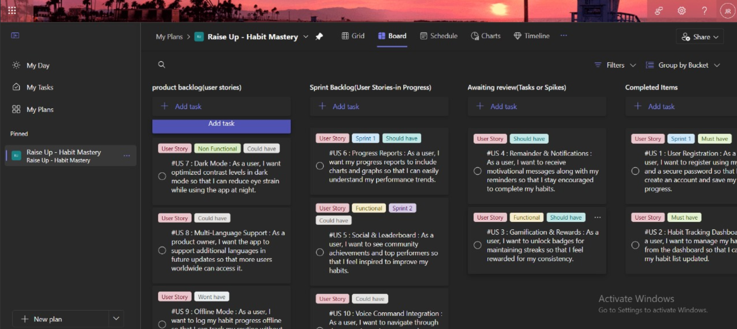

Figure 1.1 MS Planner Board of RaiseUp

**1.7 Product Release Plan**

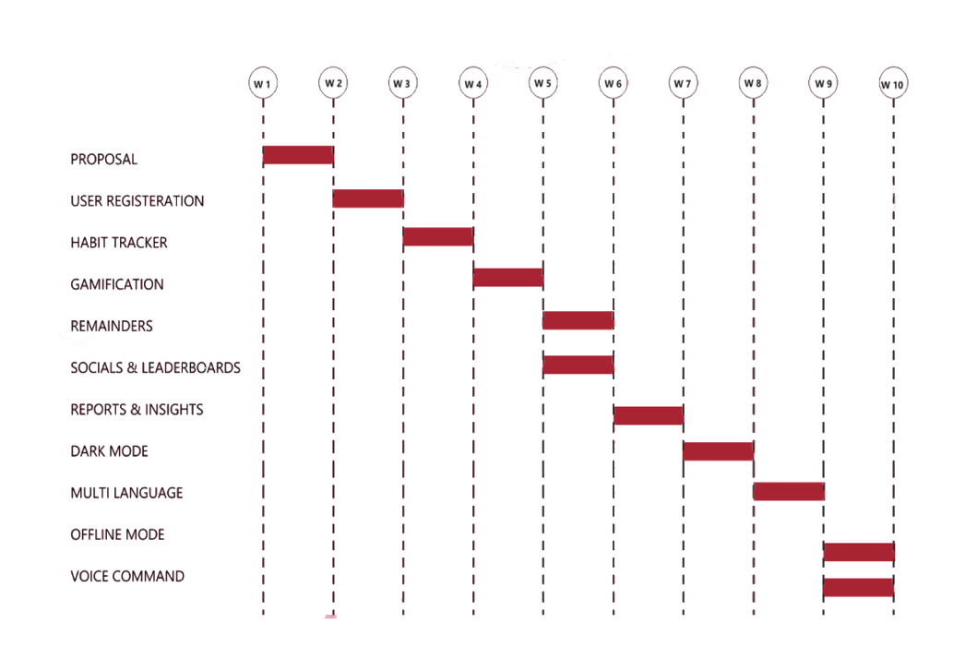

Figure 1.2 Release plan of RaiseUp

**CHAPTER 2**

**SPRINT PLANNING AND EXECUTION**

**2.1 Sprint 1**

**2.1.1 Sprint Goal with User Stories of Sprint 1**

The Goal of the first sprint is to construct the user landing page and to enable the search functionalities such as skills and courses.In Sprint 1 of the EatFit development, the primary objective was to design and implement a user-friendly, visually appealing interface, along with the functionality to generate personalized recipe suggestions based on individual dietary needs and preferences. The user stories detailed in Table 2.1.1 highlight key tasks for this sprint, which include creating an intuitive web interface that enhances user experience, building a robust recipe generation model, continuously evaluating the model's performance, and gathering user feedback for future improvements. Figures 2.1.1, 2.1.2, 2.1.3, and 2.1.4 illustrate these tasks, showing the process of building the interface, constructing the recipe generation model, evaluating its accuracy, and analyzing user feedback to refine the app further.

Table 2.1.1 Detailed User Stories of Sprint 1

|  |  |
| --- | --- |
| S.No | User Story |
| 1 | As user, The app should allow new users to register using their email and a secure password, ensuring account creation and progress tracking. The registration process should include email verification to prevent fake sign-ups and enhance security. |
| 2 | As a user, The app should reward users with badges for maintaining habit streaks, encouraging consistency and long-term engagement. Badges will be unlocked at specific milestones (e.g., 7-day, 30-day, and 100-day streaks) and displayed in the user’s profile. Users will receive notifications upon unlocking a new badge. |

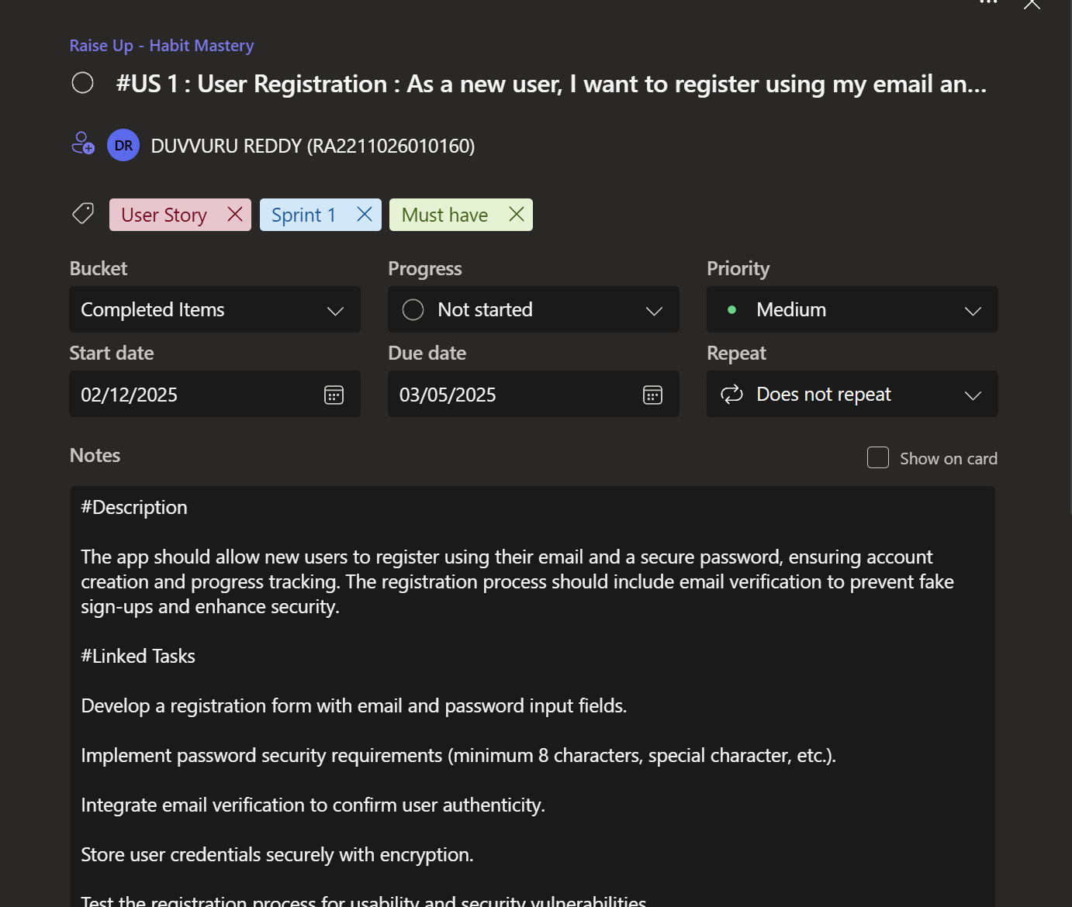 Figure 2.1.1 Building User Registeration Page 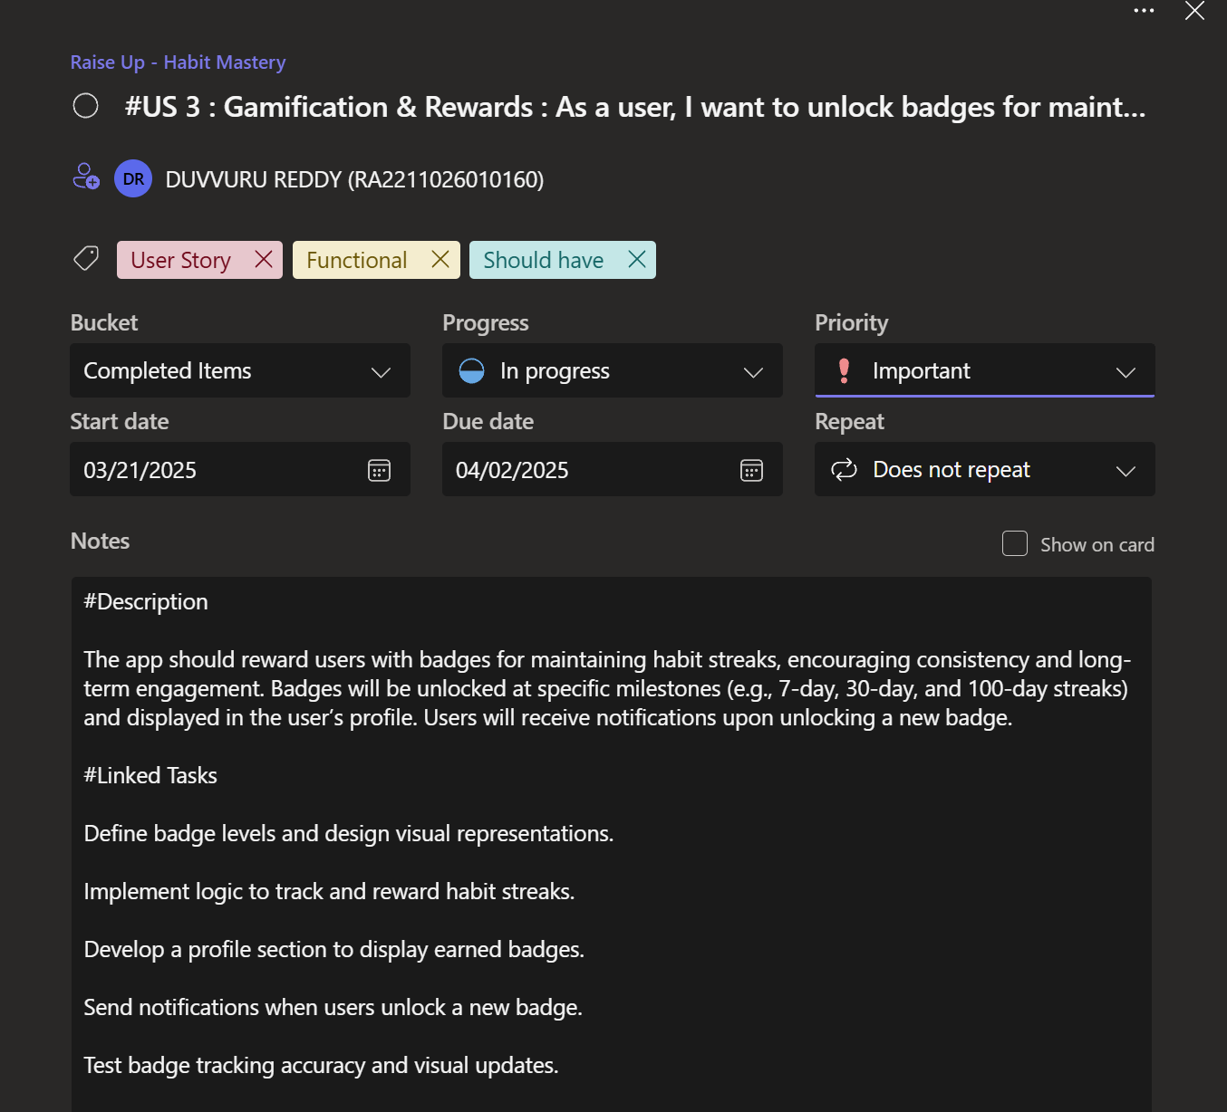 Figure 2.1.2 Building the Logic of the gamification system

**2.1.2 Functional Document**

2.1.2.1. Introduction

Raise Up is a personal development and habit tracking platform that enables users to create, monitor, and maintain  their personal challenges and goals. Built with fundamental web technologies (Python, HTML/CSS, and minimal JavaScript), it provides a straightforward solution for individuals seeking to develop consistent habits and track their progress effectively.

2.1.2.2. Product Goal

The primary goal of Raise Up is to enhance personal development through:

* Establish a secure user registration system
* Implement basic gamification features through badge rewards
* Create foundation for user engagement and habit tracking

2.1.2.3. Demography (Users, Location)

Users:

* Individuals seeking personal development
* People working on habit formation
* Students tracking academic goals

Location:

Globally accessible web application, targeting users seeking straightforward goal tracking solutions.

2.1.2.4. Business Processes

The key business processes include:

User Registration and Authentication:

* Secure login through email verification
* Password-protected account creation
* User credential encryption

Gamification System:

* Badge tracking for habit streaks
* Achievement milestone monitoring
* User notification system

2.1.2.5. Features

Sprint 1 focuses on implementing the following key features:Feature 1: User Registration (US1)

1. Description: Users can register using email and secure password
2. User Story: As a new user, I want to register using my email and a secure password, ensuring account creation and progress tracking

Feature 2: Gamification & Rewards (US3)

1. Description: Badge system for maintaining habit streaks
2. User Story: As a user, I want to unlock badges for maintaining habit streaks (7-day, 30-day, and 100-day streaks)

Table 2.1.2 Access level Authorization Matrix for Sprint 1

| Role | Access Level |
| --- | --- |
| New User | Register account, verify email. |
| Registered User | Track Habits, Earn Badges, View profile. |

In Sprint 1 of Raise Up development, the access level authorization matrix establishes basic user roles and permissions. New users can register and verify their accounts, while registered users gain access to habit tracking and badge earning features. This ensures a secure and structured approach to user management and feature access.

2.1.2.7. Assumptions

* Users will provide valid email addresses for verification
* Email verification will enhance security
* Badge system will motivate consistent usage
* Users will regularly track their habits
* Basic security measures will be sufficient for initial release

**2.1.3 Architecture Document**

2.1.3.1. Application

Core Components: The Raise Up Sprint 1 implements two primary services:

1. Authentication Service:

* Manages user registration form with email/password inputs
* Implements password security requirements
* Handles email verification
* Secures user credential storage
* Provides registration testing capabilities

1. Gamification Service:

* Defines and tracks badge levels
* Implements habit streak monitorin0067
* Manages achievement display
* Handles badge unlock notifications

As shown in Figure 2.1.1 (Building User Registration Page), the registration system implements a secure user authentication flow with email verification and encrypted storage. Figure 2.1.2 (Building the Logic of the gamification system) demonstrates the badge system's architecture, showing how user achievements are tracked and rewarded through various milestone completions.

2.1.3.2 System Architecture

The system architecture for Sprint 1 adopts a clear and modular approach, built around two primary components operating in tandem: the User Registration System and the Gamification System. The User Registration System (Figure 2.1.1) is responsible for handling the user onboarding process. It features a user-friendly frontend registration form designed for ease of access, backed by robust backend validation and security protocols to ensure data integrity and prevent unauthorized access. An integrated email verification system strengthens user authenticity, while secure storage practices protect sensitive user information against breaches. Complementing this, the Gamification System (Figure 2.1.2) enhances user engagement by implementing a dynamic badge tracking mechanism, monitoring achievement milestones, and integrating these accomplishments into individual user profiles. A real-time notification system keeps users informed about their progress and rewards, thereby fostering continuous interaction. Both systems are designed to interact seamlessly yet maintain a clear separation of concerns, which not only improves maintainability and scalability but also allows for independent upgrades or refinements without impacting overall system stability.

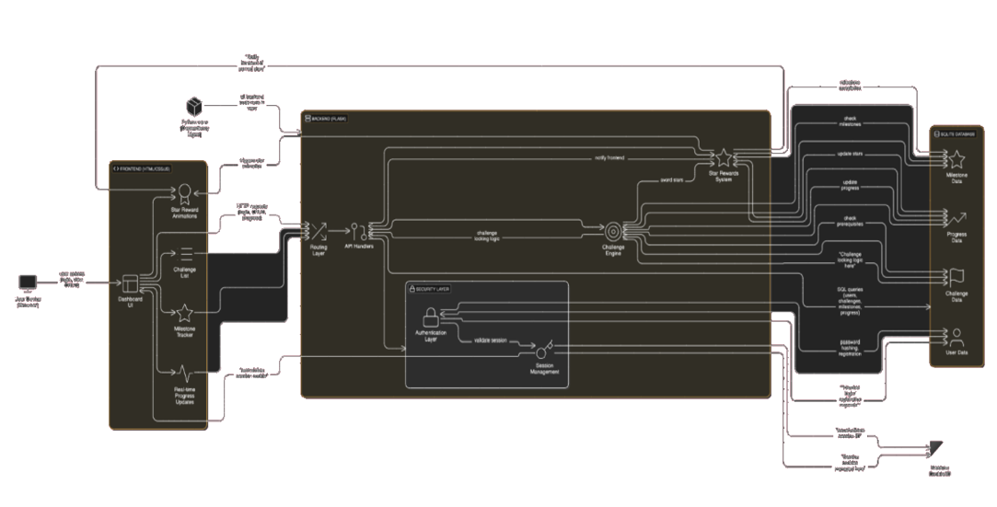

Figure 2.1.3 System Architecture Diagram

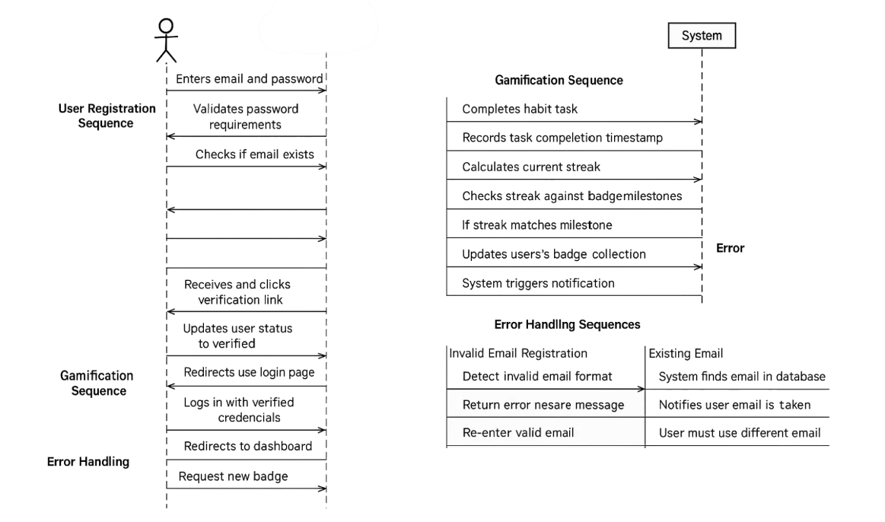

Figure 2.1.4 Sequence Diagram

2.1.3.3. Data Exchange Contract:

The sequence flow for Sprint 1 of Raise Up demonstrates the interconnected processes of user registration and gamification features. The user journey begins with registration, where users enter their email and password into the system. The authentication process includes crucial security steps: password validation (minimum 8 characters with special characters), email uniqueness verification, and secure account creation. Upon successful validation, the system generates and sends a verification email, requiring users to confirm their identity through a verification link. Once verified, users gain access to their personalized dashboard where they can begin tracking habits. The gamification sequence initiates as users engage with the platform, where the system continuously monitors habit completion streaks. When users achieve specific milestones (7-day, 30-day, or 100-day streaks), the system automatically triggers the badge reward mechanism, updating their profile with new achievements and sending notifications to acknowledge their progress. This systematic flow ensures secure user authentication while maintaining engaging user interaction through immediate feedback and reward systems, creating a seamless experience from initial registration to ongoing habit tracking and achievement recognition.

**2.1.4 UI DESIGN**

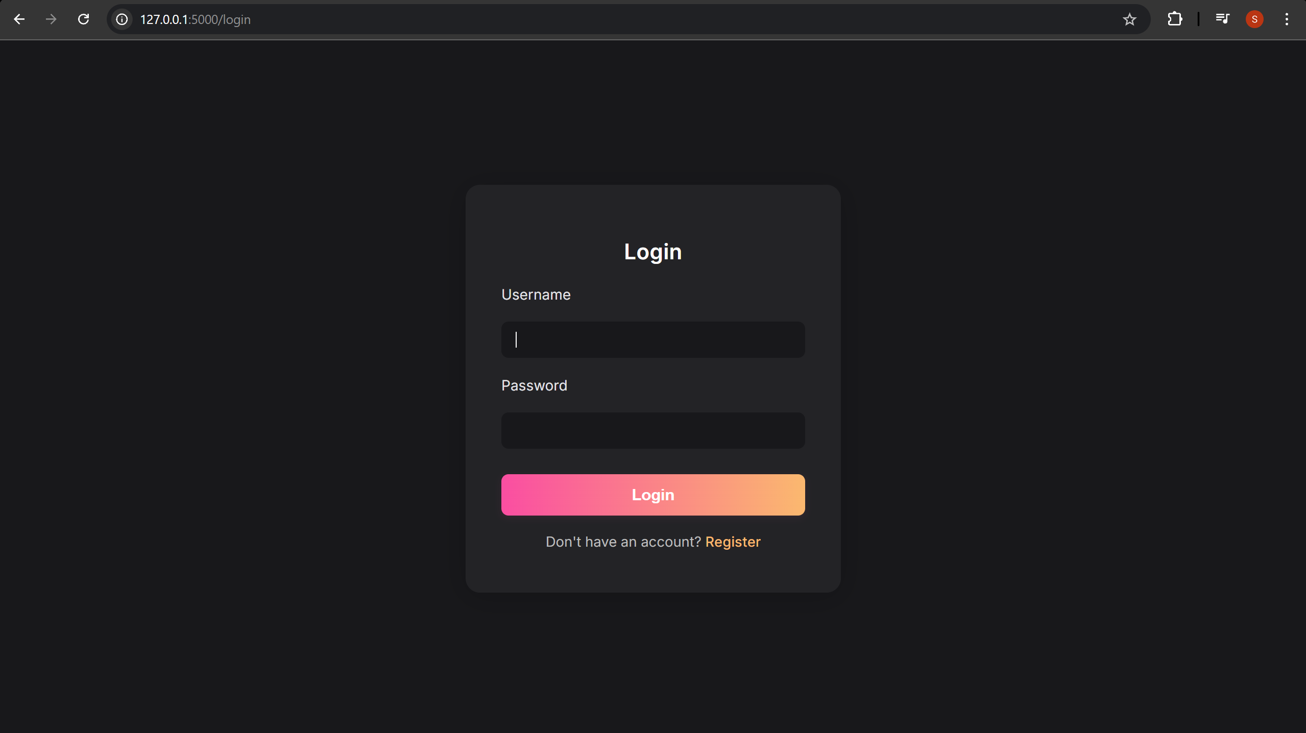

Figure 2.1.5 UI Design of Login Page

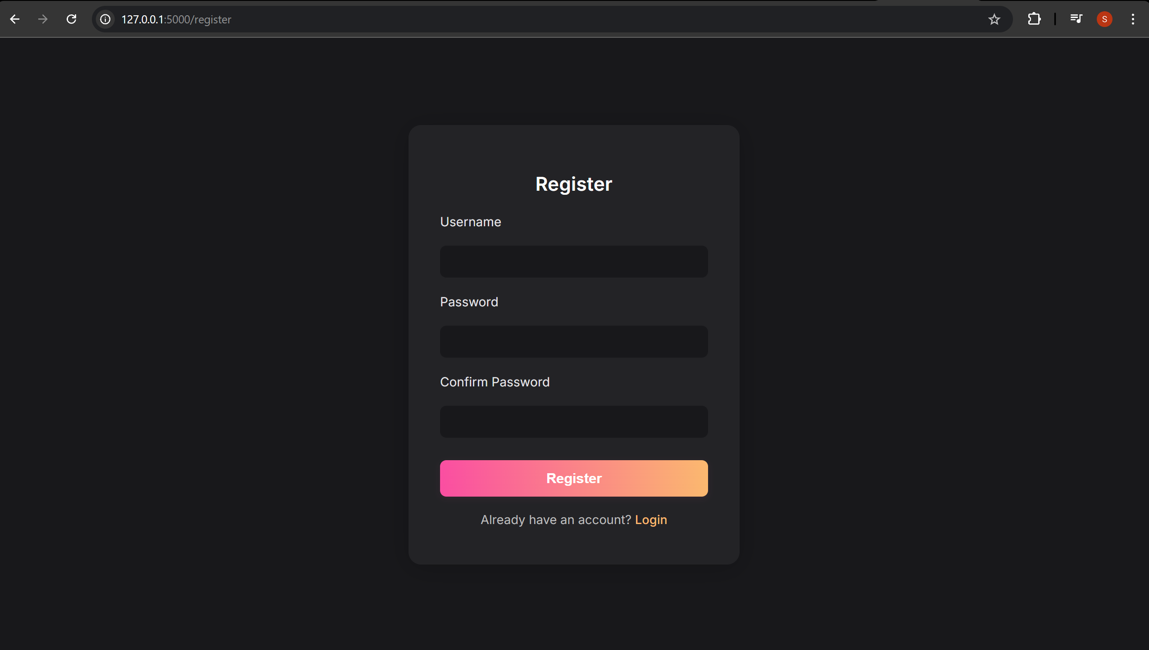

Figure 2.1.6 UI Design of Register Page

**2.1.5 Functional Test Cases**

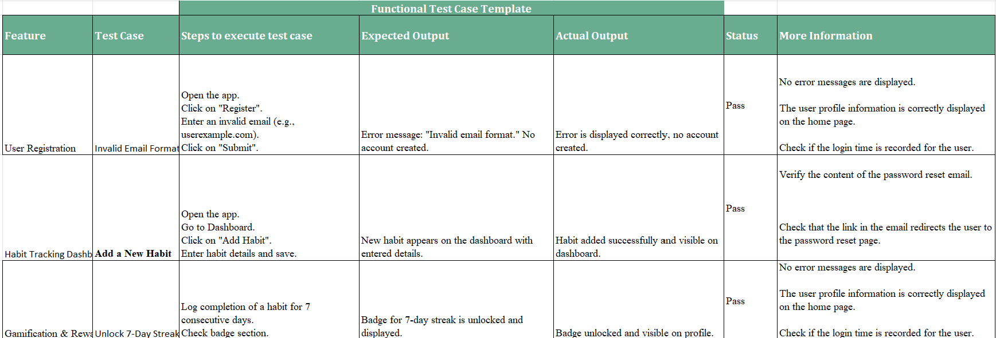

Figure 2.1.7 Functional Test Cases for the Sprint 1

The functional test case template outlines various test scenarios to validate core features of the application, including user registration, habit tracking, and gamification rewards. Each test case includes detailed steps, expected outcomes, and actual results, along with a status report and additional notes. For instance, the "Invalid Email Format" test under User Registration ensures proper error handling when an invalid email is submitted, confirming that no account is created. for thorough validation.

**2.1.6 Sprint Retrospective**

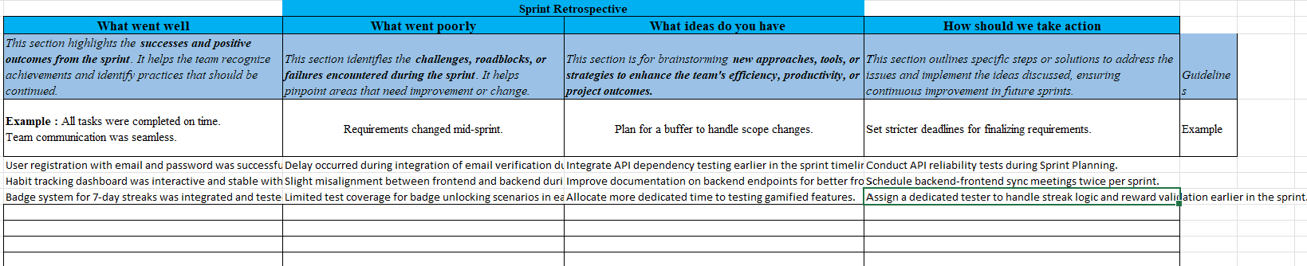

Figure 2.1.8 Sprint Retrospective for the Sprint 1

The sprint retrospective provided valuable insights into the team's progress, highlighting both achievements and areas for growth. Key successes included the smooth implementation of user registration with email and password, a stable and interactive habit tracking dashboard, and the successful integration of the 7-day badge reward system. However, the sprint also faced notable challenges such as mid-sprint requirement changes, integration delays related to email verification, frontend-backend misalignment, and insufficient test coverage for gamified features. In response, the team proposed actionable improvements, such as initiating API testing earlier in the sprint, enhancing backend documentation, and dedicating more focused testing on rewards. Concrete steps like stricter requirement finalization deadlines, scheduled sync meetings, and dedicated testing roles were outlined to improve future sprint efficiency and delivery.

**2.2 SPRINT 2**

**2.2.1 Sprint Goal with User Stories of Sprint 2**

For Sprint 2 of Raise Up focuses on enhancing user engagement and accessibility through the implementation of social features and offline capabilities. The sprint encompasses two critical user stories that expand the application's functionality beyond basic habit tracking. US5 (Social & Leaderboard) introduces a community-driven feature where users can view a dynamic leaderboard showcasing top performers and community achievements, with rankings based on habit streaks and completion rates. This feature aims to foster healthy competition and motivation through real-time updates of rankings and achievements, complete with a dedicated section highlighting milestone achievers.

Table 2.2.1 Detailed User Stories of sprint 2

|  |  |
| --- | --- |
| S.NO | Detailed User Stroy |
| 6 | As a user, The app should display a leaderboard showcasing top performers and community achievements to motivate users. Users can see rankings based on streaks, habit completion, and consistency. |
| 7 | As a user, The app should allow users to log their habit progress even when offline, ensuring uninterrupted tracking. Users can mark habits as completed, and the system will store the data locally. |

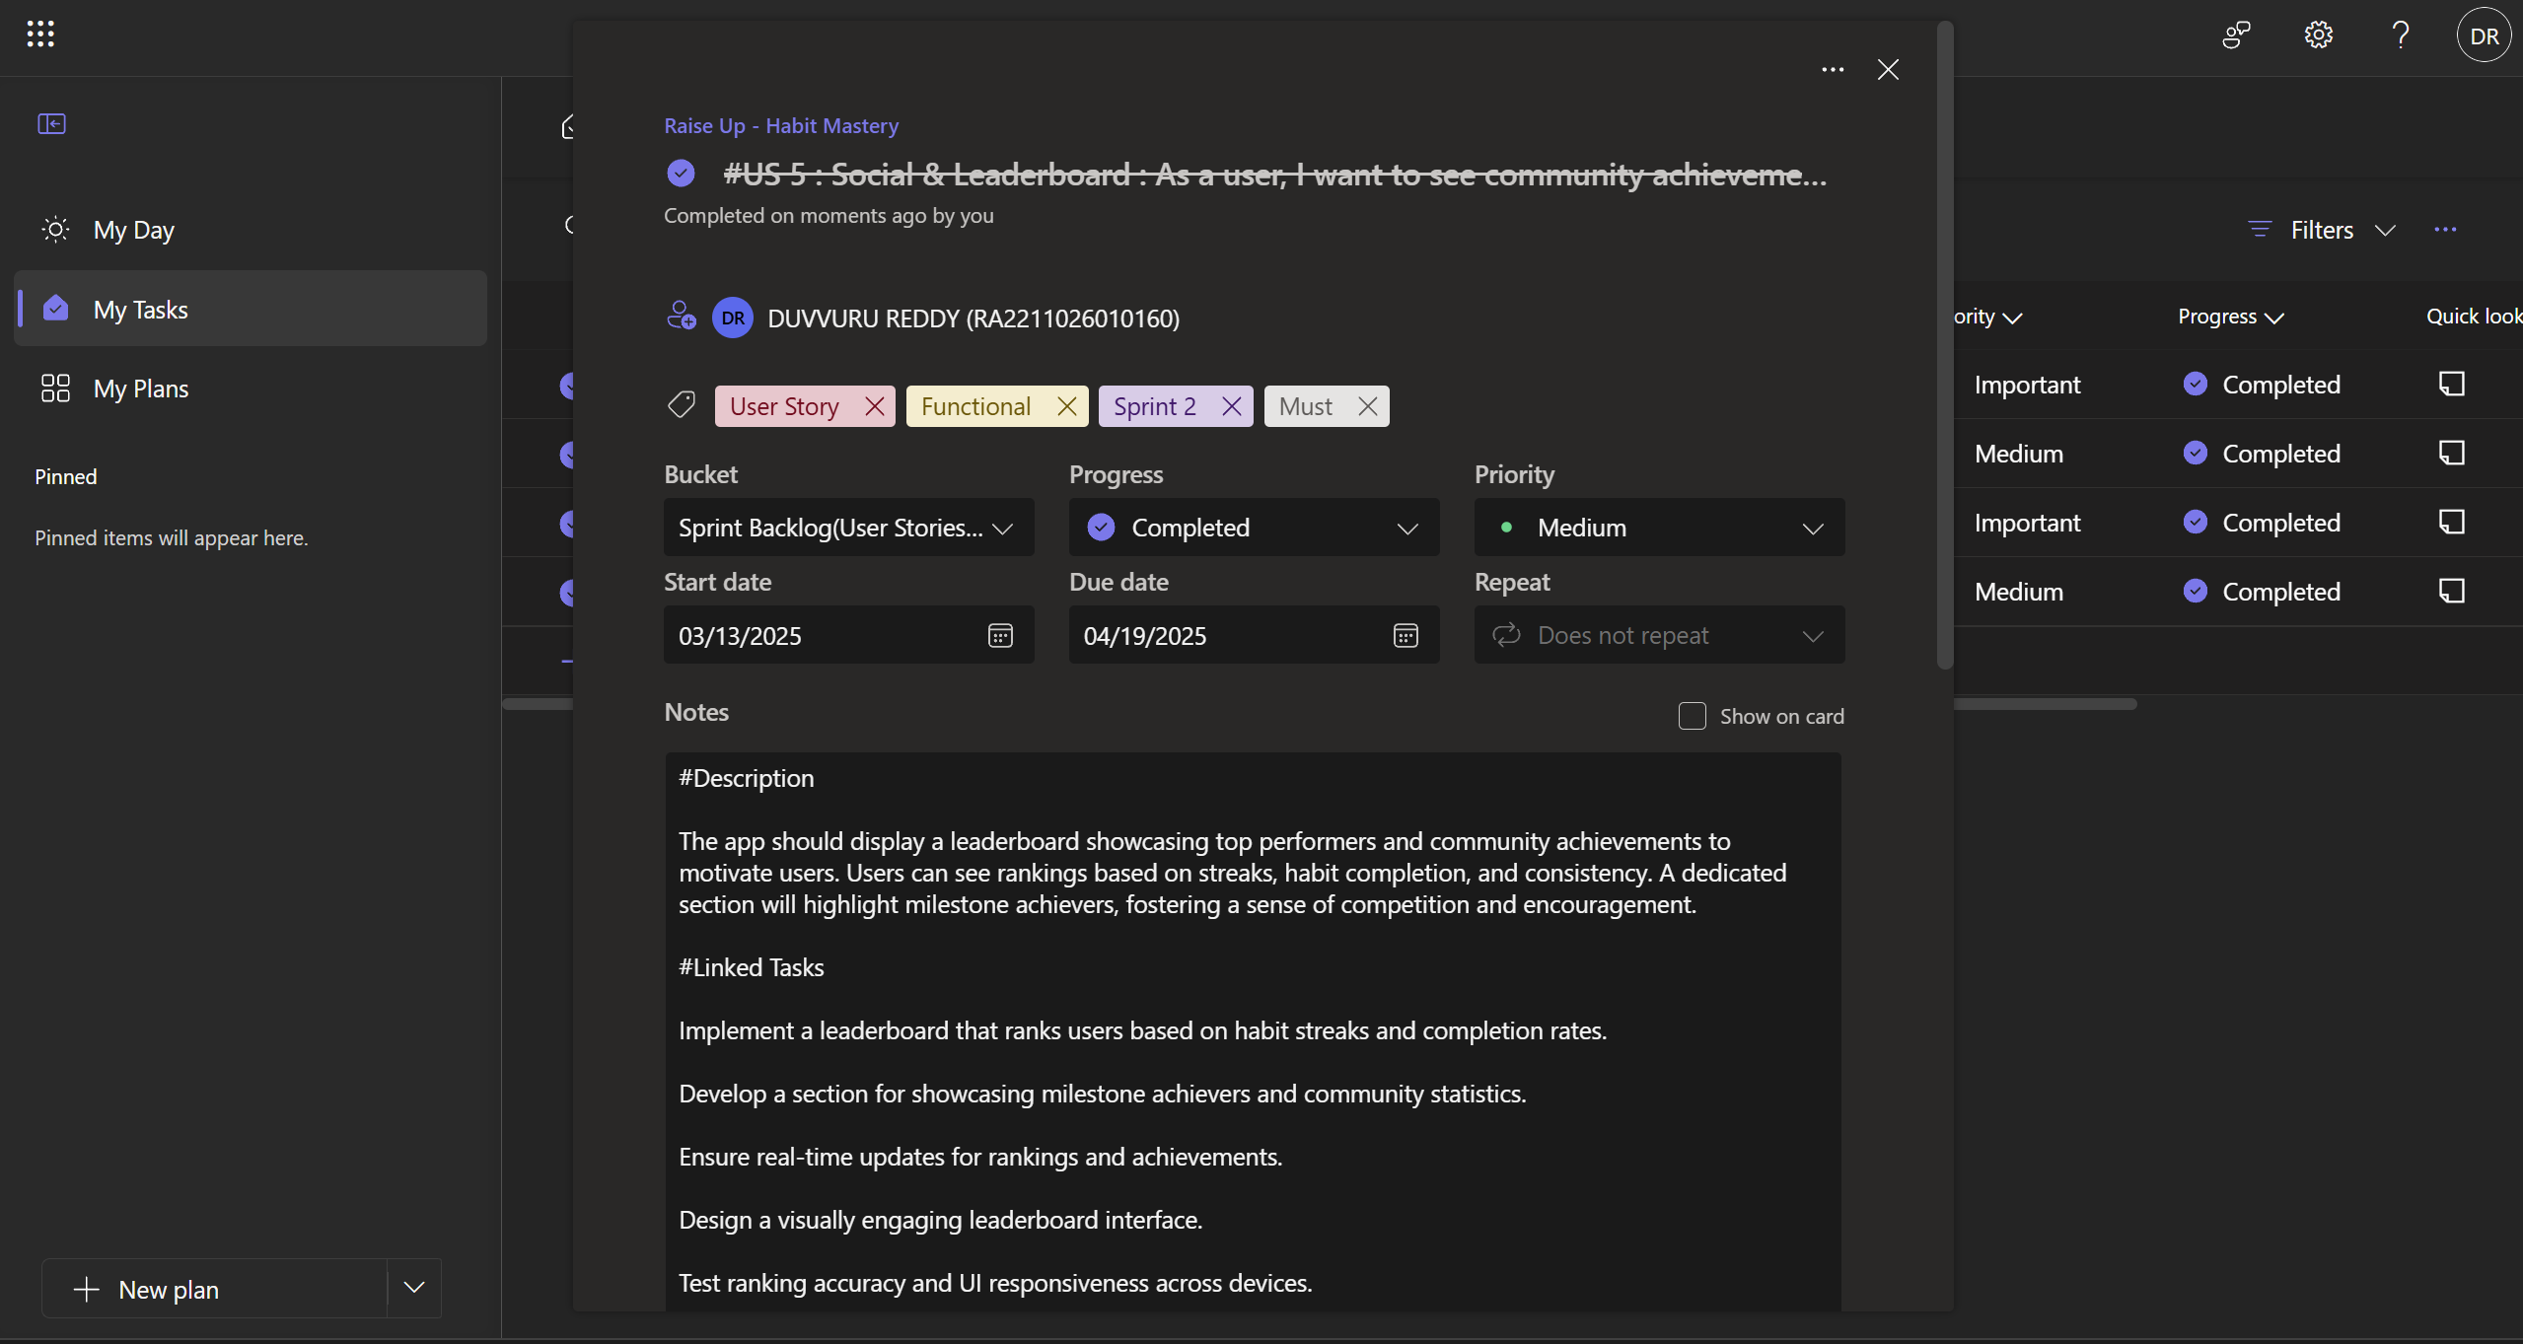

Figure 2.2.1 Implementation of Leaderboards

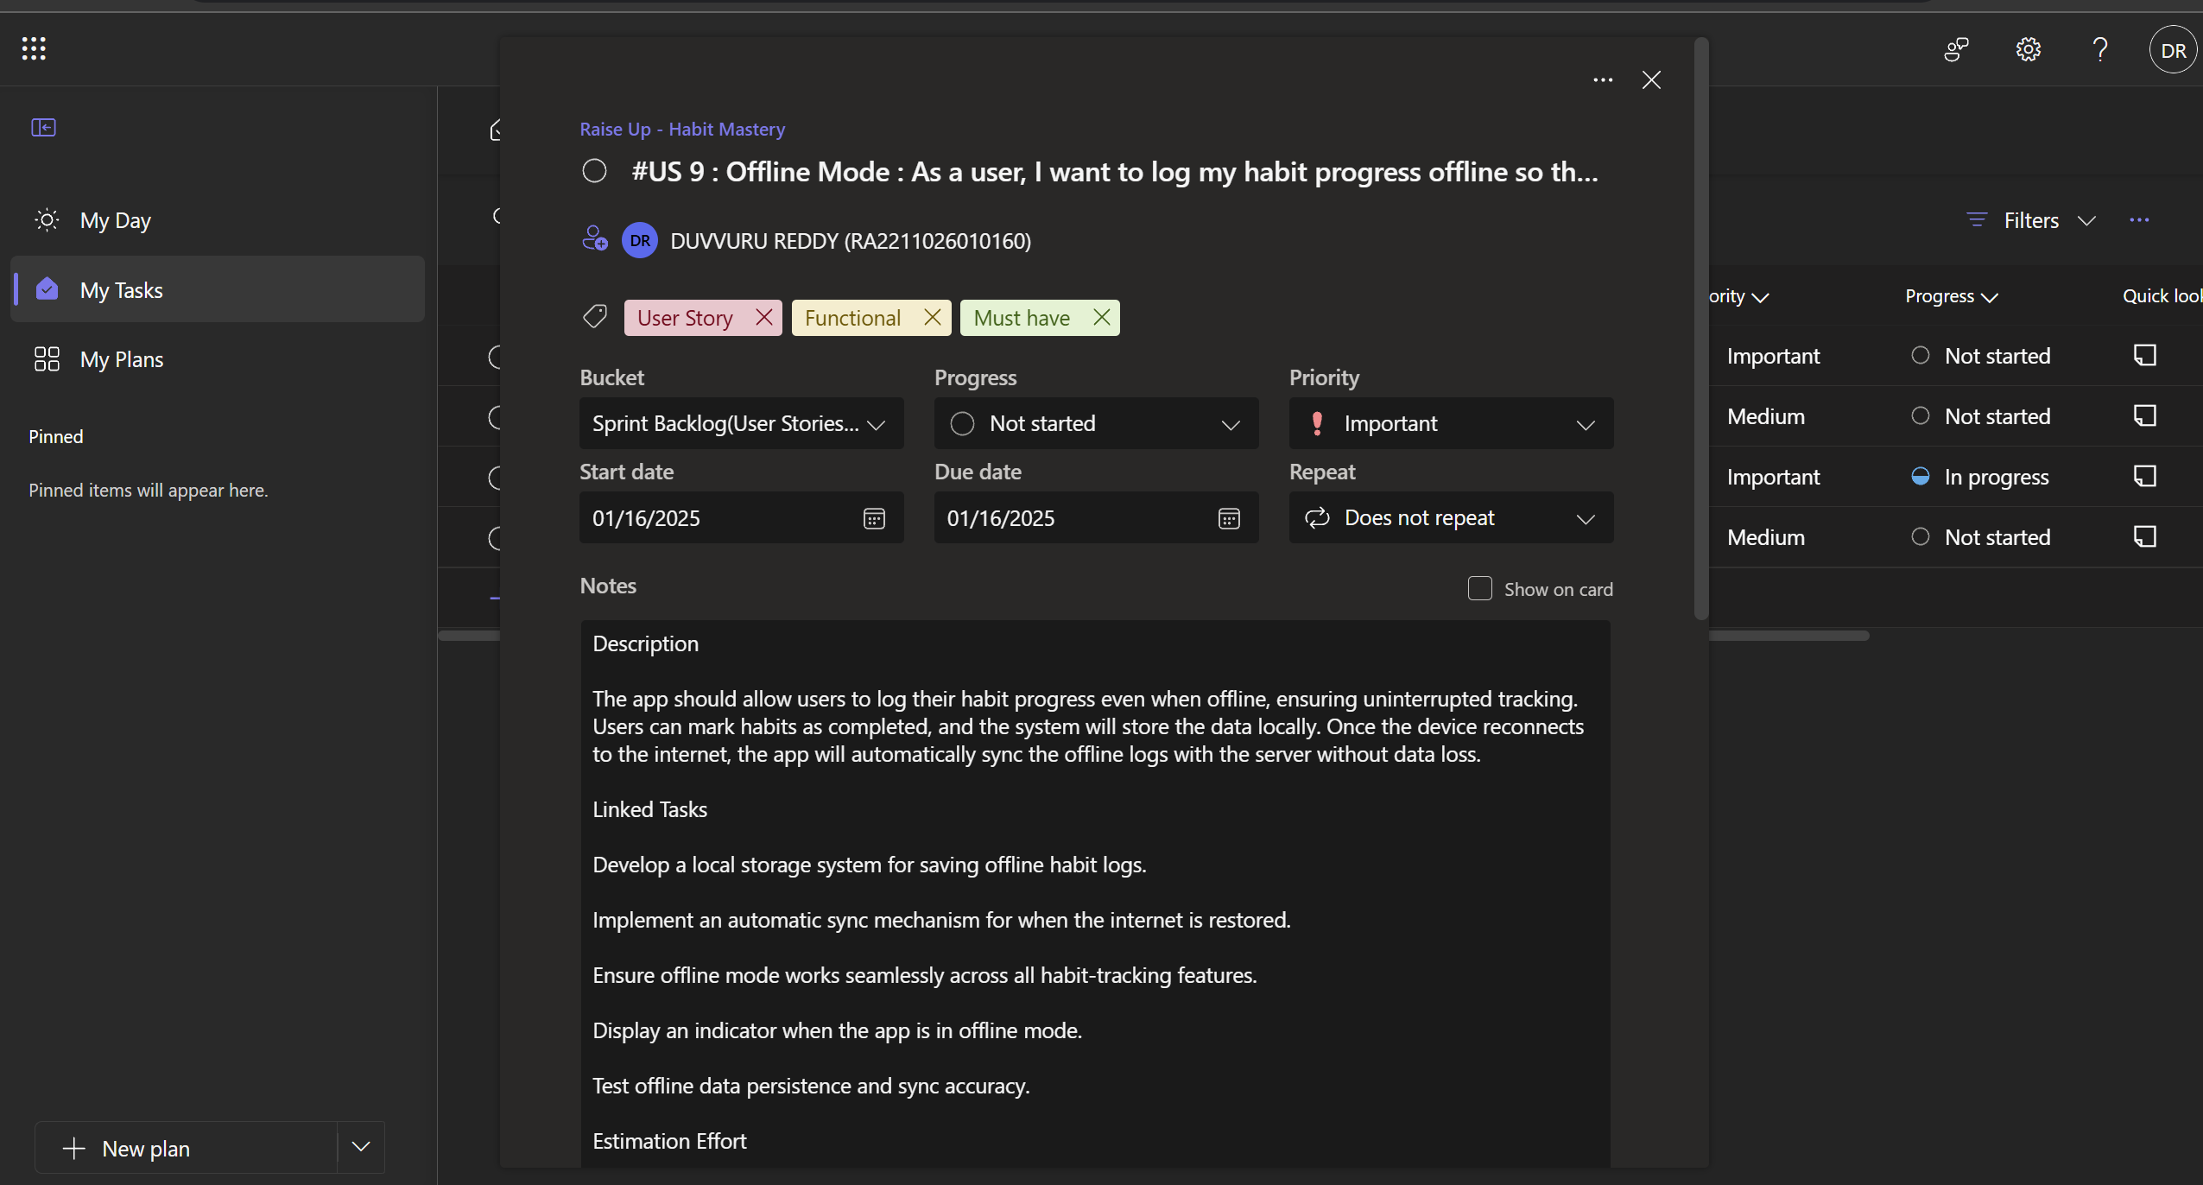

Figure 2.2.2 Implementation of Offline System

**2.2.2 Functional Document**

2.2.2.1. Introduction

In Sprint 2 of the Raise Up project focuses on expanding the platform's social and offline capabilities. This sprint introduces two major features: a community leaderboard system to foster healthy competition and an offline mode to ensure uninterrupted habit tracking, enhancing the application's usability and engagement factors.

2.2.2.2. Product Goal

Refine and expand functionality with:

* Create a competitive community environment through leaderboards
* Enable continuous habit tracking regardless of internet connectivity
* Foster user engagement through social features
* Ensure data persistence across online and offline states

2.2.2.3. Demography (Users, Location)

Users:

* Existing users seeking community engagement
* Competitive individuals
* Users with unreliable internet connections

Location:

* Global accessibility with focus on areas with varying internet connectivity

2.2.2.4. Business Processes

The key business processes include:

* User ranking calculation
* Real-time achievement updates
* Community statistics tracking
* Milestone showcasing

Offline Mode:

* Local data storage
* Automatic synchronization
* Offline state management
* Data persistence handling

2.2.2.5. Features

* Sprint 2 implements the following key features:Feature 1: Social & Leaderboard (US5)
* Description:
* Leaderboard displaying top performers
* Community achievement showcase
* User Story:
* As a user, I want to see community achievements and rankings to stay motivated
* Implementation Tasks:
* Implement ranking system
* Create milestone achievers section
* Ensure real-time updates

2.2.2.6. Authorization Matrix

The Access Level Authorization Matrix for Sprint 2, shown in Table 2.1.2, establishes clear role-based permissions for the enhanced social and offline features of Raise Up. Regular users gain access to the new community leaderboard system, allowing them to view rankings, track their position among peers, and participate in the competitive aspects of habit tracking. They can also utilize the offline mode functionality, enabling them to log habits without internet connectivity and access cached versions of their progress data. The offline user role is specifically designed to maintain core functionality during disconnected periods, allowing continued habit logging with local storage and access to previously synchronized leaderboard data.

Table 2.2.2 Access level Authorization Matrix for Sprint 2

| Role | Access Level |
| --- | --- |
| User | View leaderboard, Track offline progress, view community achievements |
| Offline User | Log Habits locally, view cached leaderboard |

2.2.2.7. Assumptions

* Local storage will be sufficient for offline data
* Users will engage with competitive features
* Real-time updates won't overload the system
* Users will regularly sync their offline progress

**2.2.3 Architecture Document**

2.2.3.1. Application

Core Components:

1. Leaderboard Service:

* Ranking calculation system
* Achievement tracking
* Real-time update mechanism
* Community statistics management

1. Offline Mode Service:

* Local storage management
* Sync coordination
* Data persistence handling
* Connection state monitoring

The architecture is supported by the user stories shown in the images, detailing the leaderboard implementation (US5) and offline mode functionality (US9).

2.2.3.1**.** System Architecture

Sprint 2's architecture introduces two major new components designed to enhance both the social engagement and offline usability of the system. The first of these is the Social & Leaderboard System, which includes a real-time ranking engine that dynamically updates user standings, an achievement tracking database that records and maintains user accomplishments, and a community statistics processor that aggregates data across the user base to provide meaningful insights into overall trends and behaviors. Additionally, a set of dedicated UI components have been developed to ensure seamless and visually coherent leaderboard display within the application, enabling users to engage more deeply with their progress and compare it against others in the community. The second major addition is the Offline Mode System, which addresses the need for uninterrupted functionality in low or no connectivity scenarios.

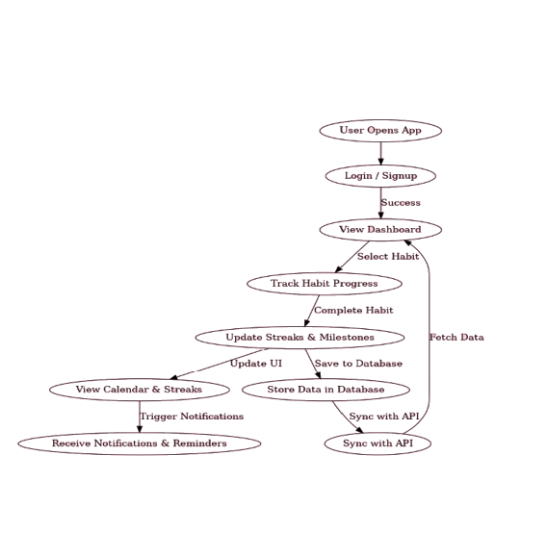

Figure 2.2.3 Data Flow Diagram Level

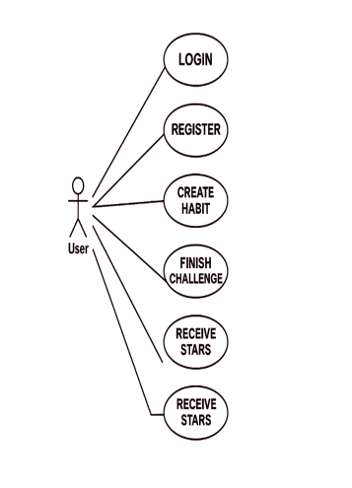

Figure 2.2.4 Use Case Diagram

The Architecture Document is described in Figure 2.2.3, providing a visual representation of the system's architecture and how different components interact within the EatFit application. Similarly, Figure 2.2.4 illustrates the Use Case Diagram, showcasing the various user interactions with the system and highlighting the key functionalities from the user’s perspective.

**2.2.4 UI Design**

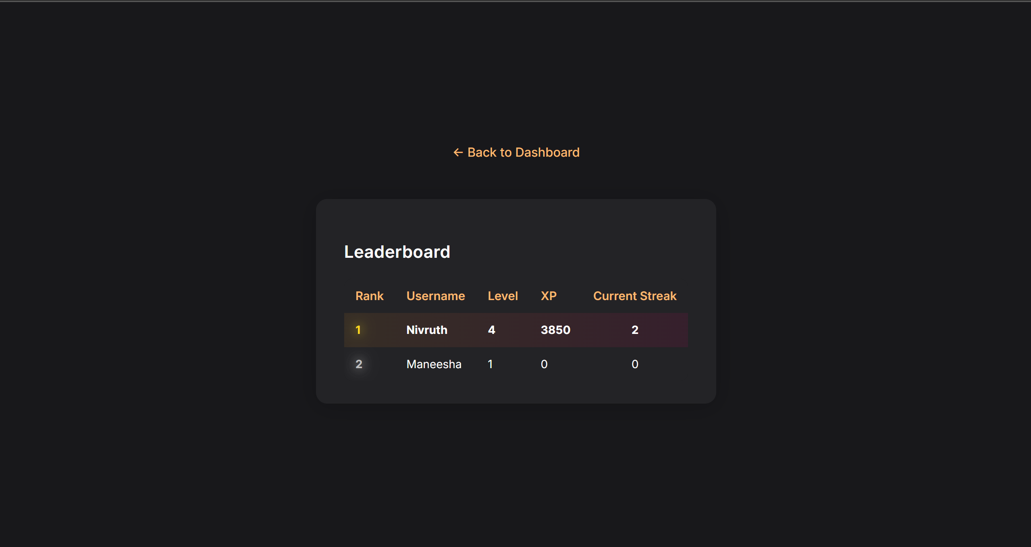

Figure 2.2.5 UI displays the leaderboards of fellow people

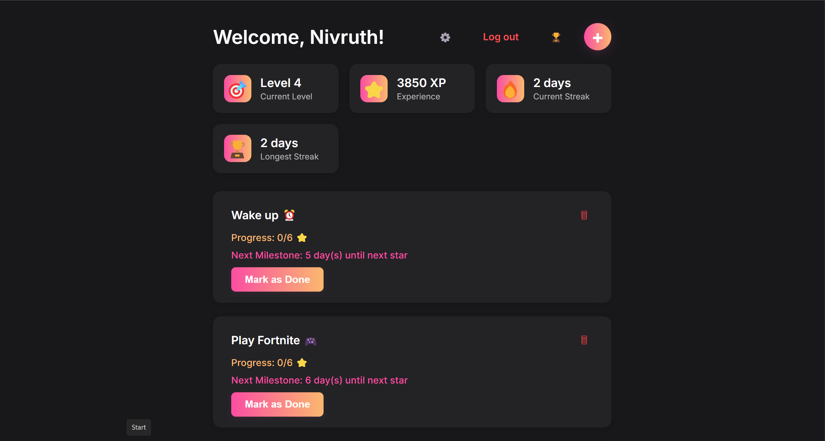

Figure 2.2.6 UI displays all the habits that are created, offline mode locally

**2.2.5 Functional Test Cases**

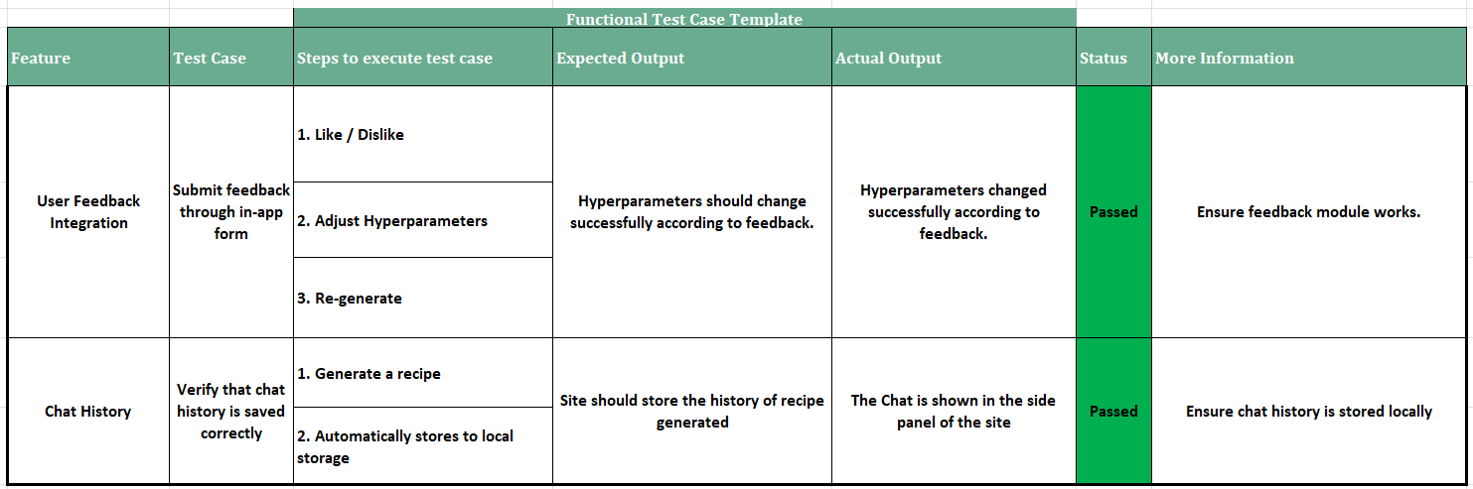

Figure 2.2.7 Functional Test Cases for the Sprint 2

**2.2.6 Sprint Retrospective**

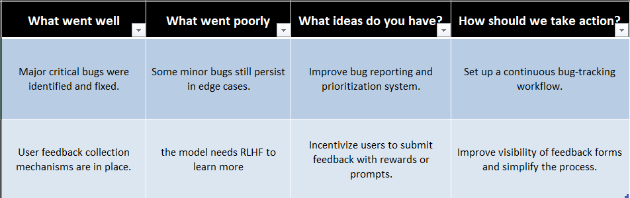

Figure 2.2.8 Sprint Retrospective for the Sprint 2

Figure 2.2.8 highlights the UI displaying a healthy recipe suggestion generated by EatFit, showcasing the personalized meal recommendations for users. The Functional Test Cases for Sprint 2 are detailed in Figure 2.2.9, validating the key features and functionality of the app. Additionally, Figure 2.2.10 captures the Standup meetings for Sprint 2, reflecting the team's daily progress and discussions. The Bar Graph for Committed Vs Completed User Stories for Sprint 2, shown in Figure 2.2.11, compares the initially committed user stories with the completed ones, offering insights into the team's progress. Lastly, Figure 2.2.12 presents the Sprint Retrospective for Sprint 2, which reflects on the outcomes and identifies areas for improvement following the sprint.

**CHAPTER 3**

**RESULTS AND DISCUSSION**

**3.1 Project Outcomes**

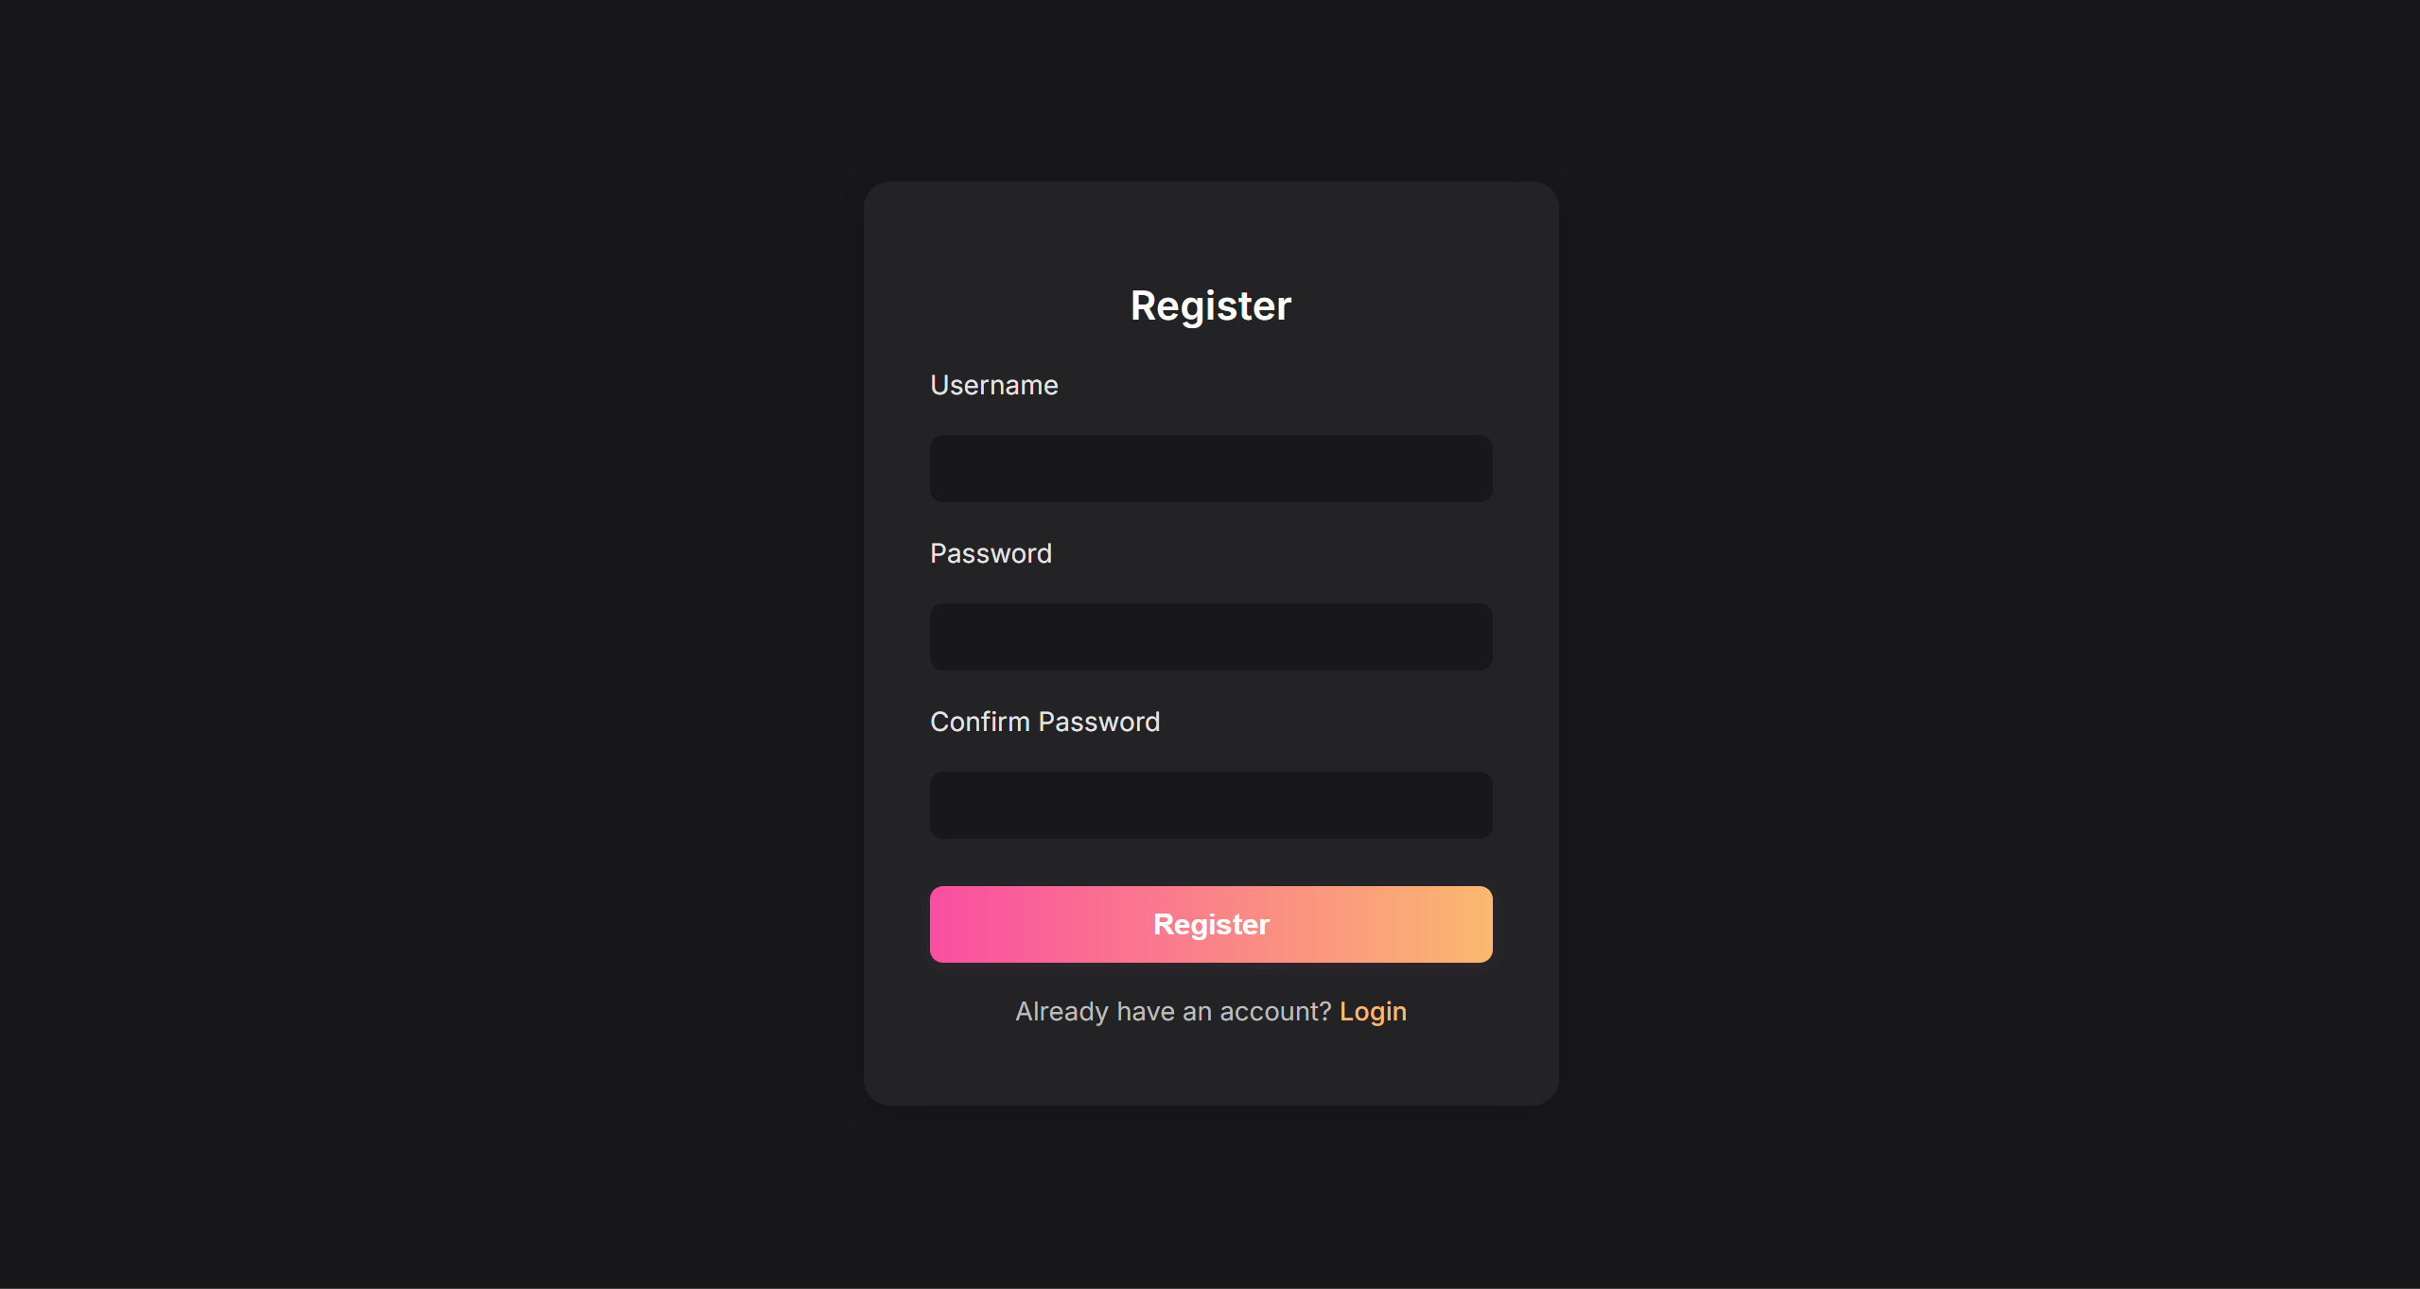

Figure 3.1 Sign up Page

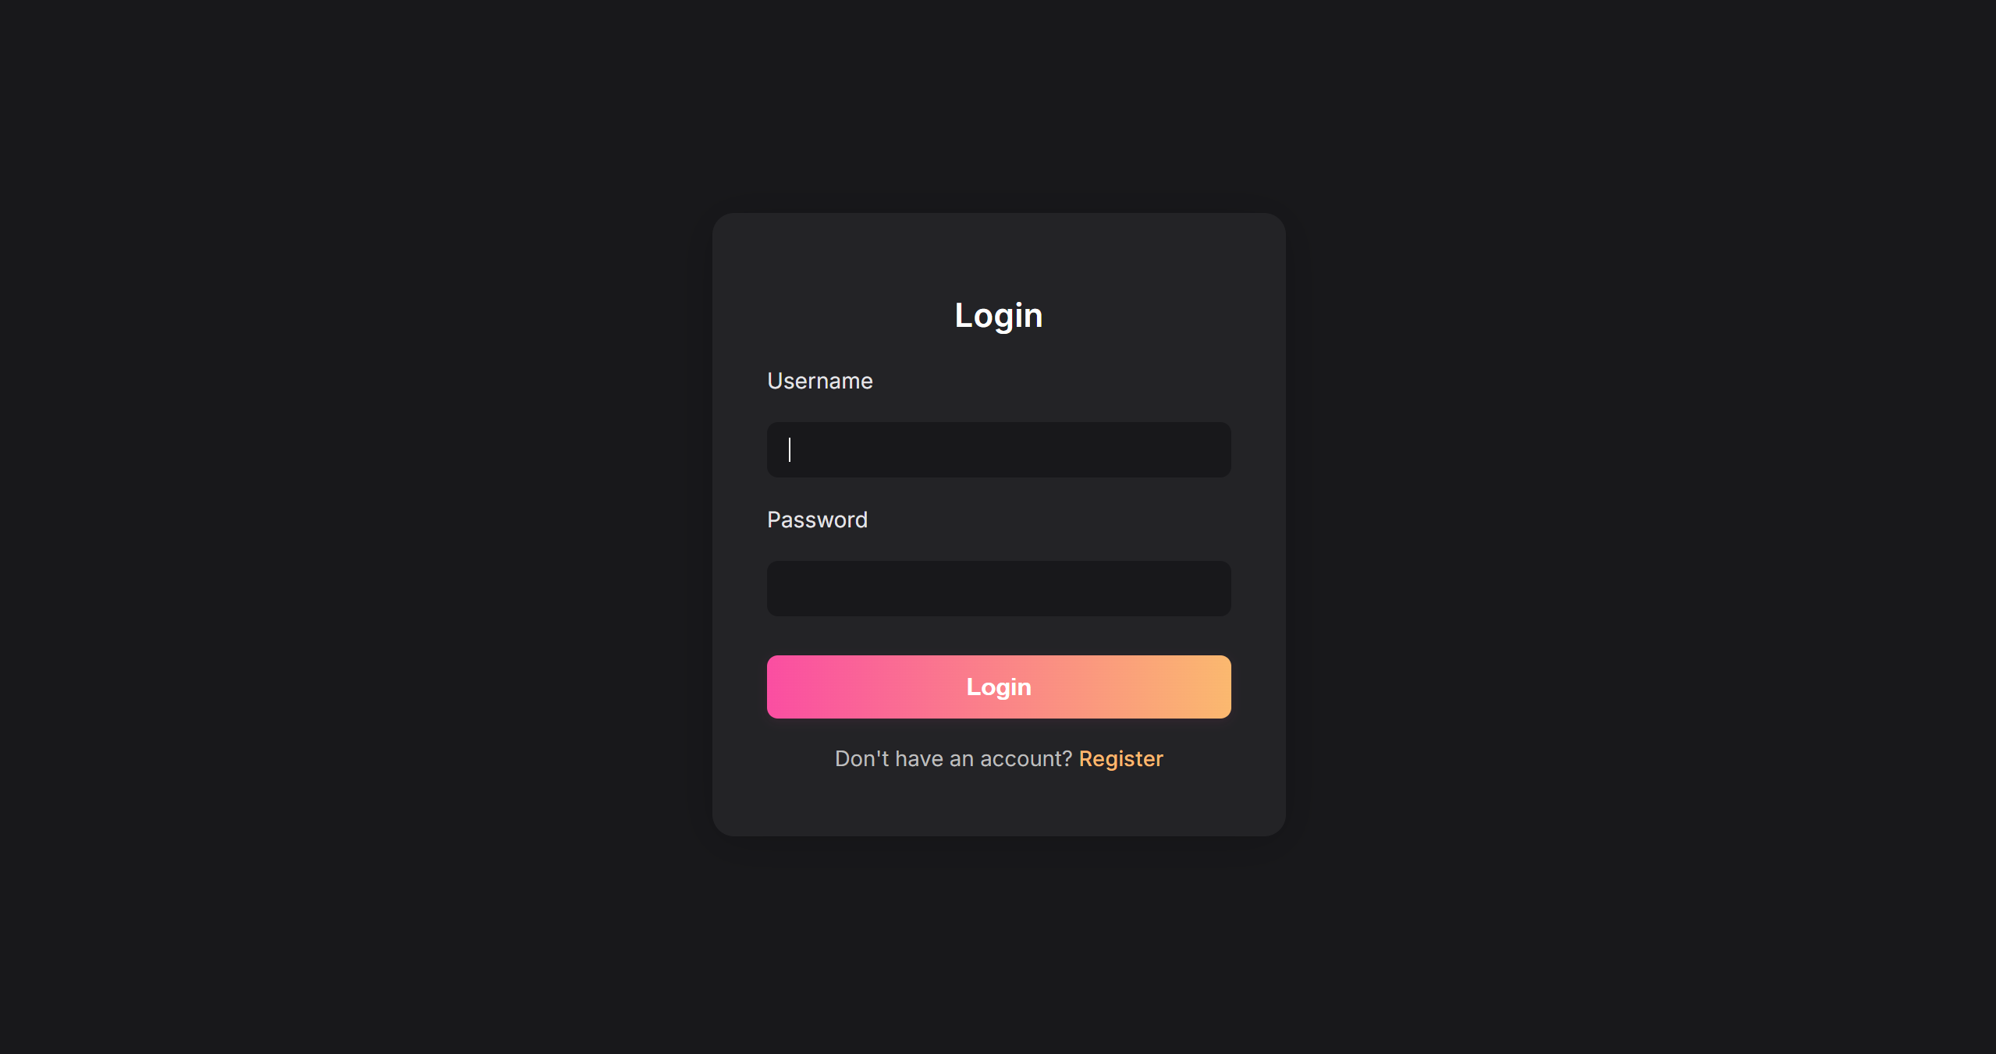Figure 3.2 Log in page

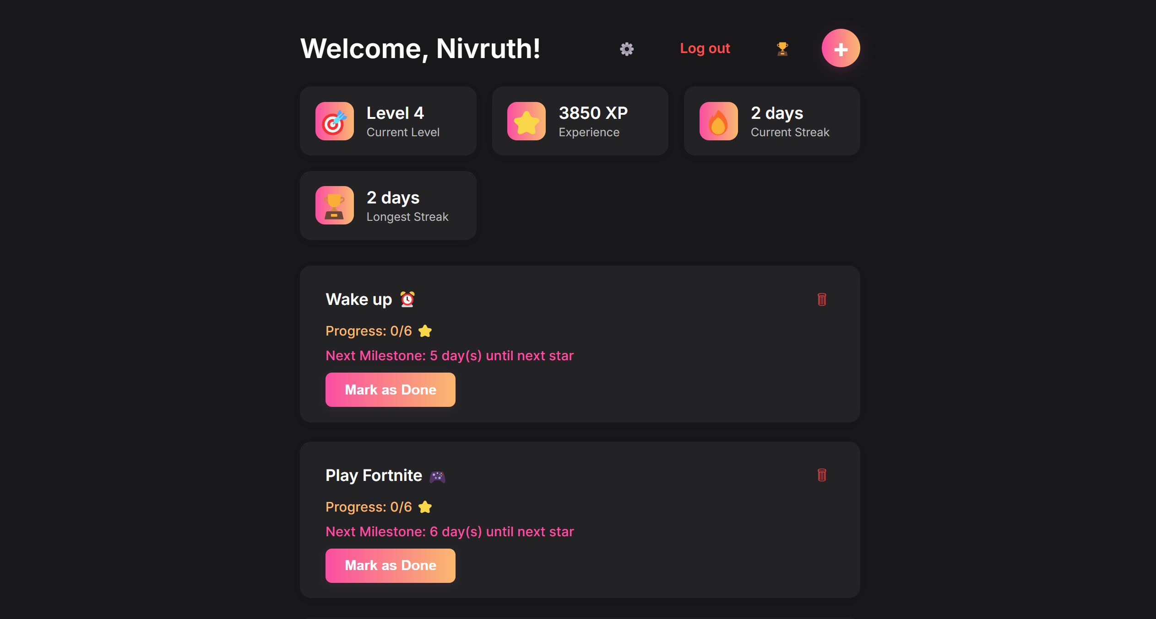Figure 3.3 User Dashboard

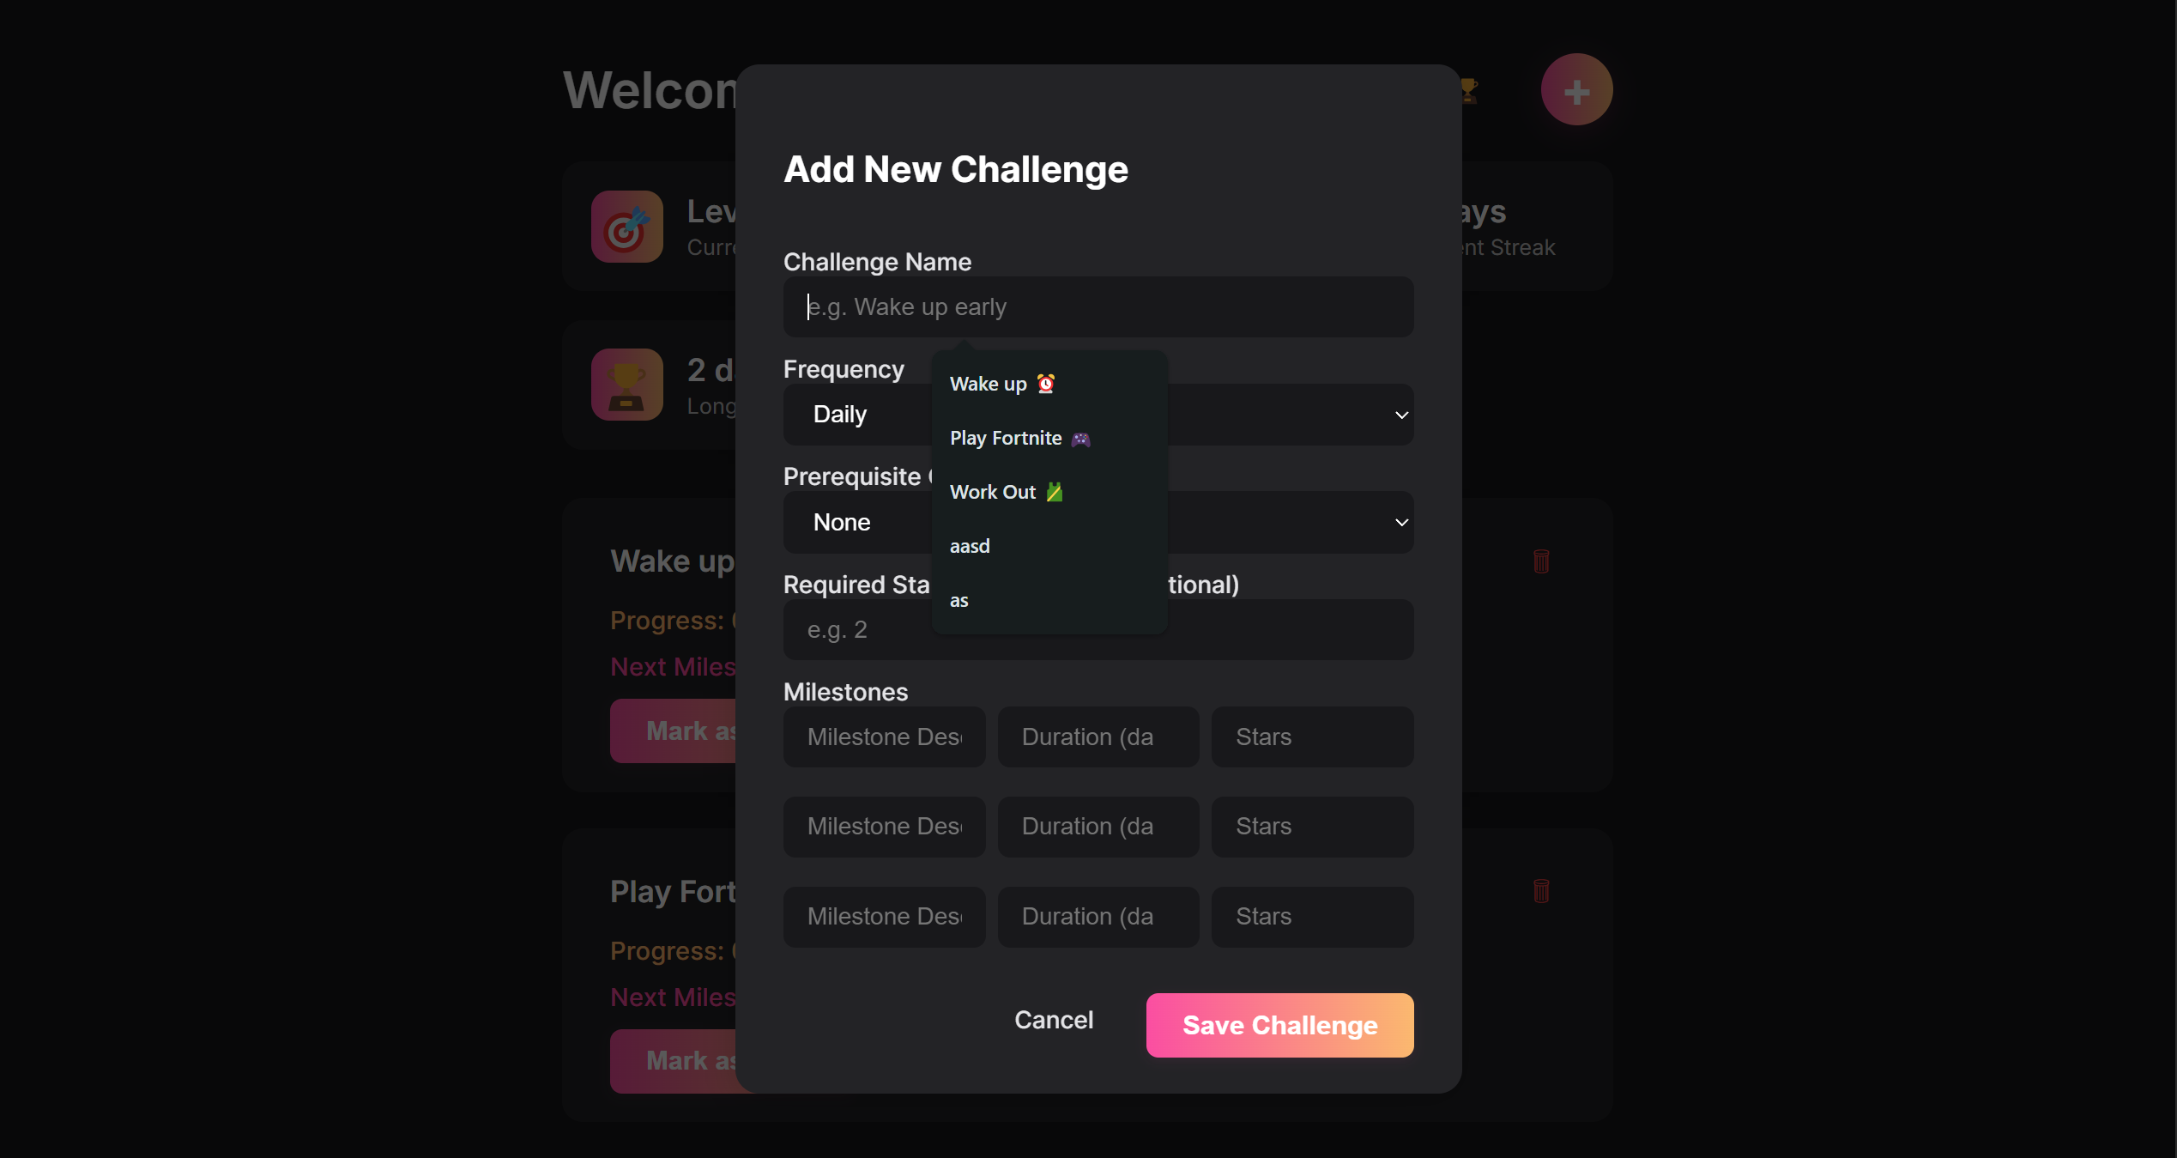

Figure 3.4 User can add challenges / Pre-requisites



Figure 3.5 Leaderboards Page

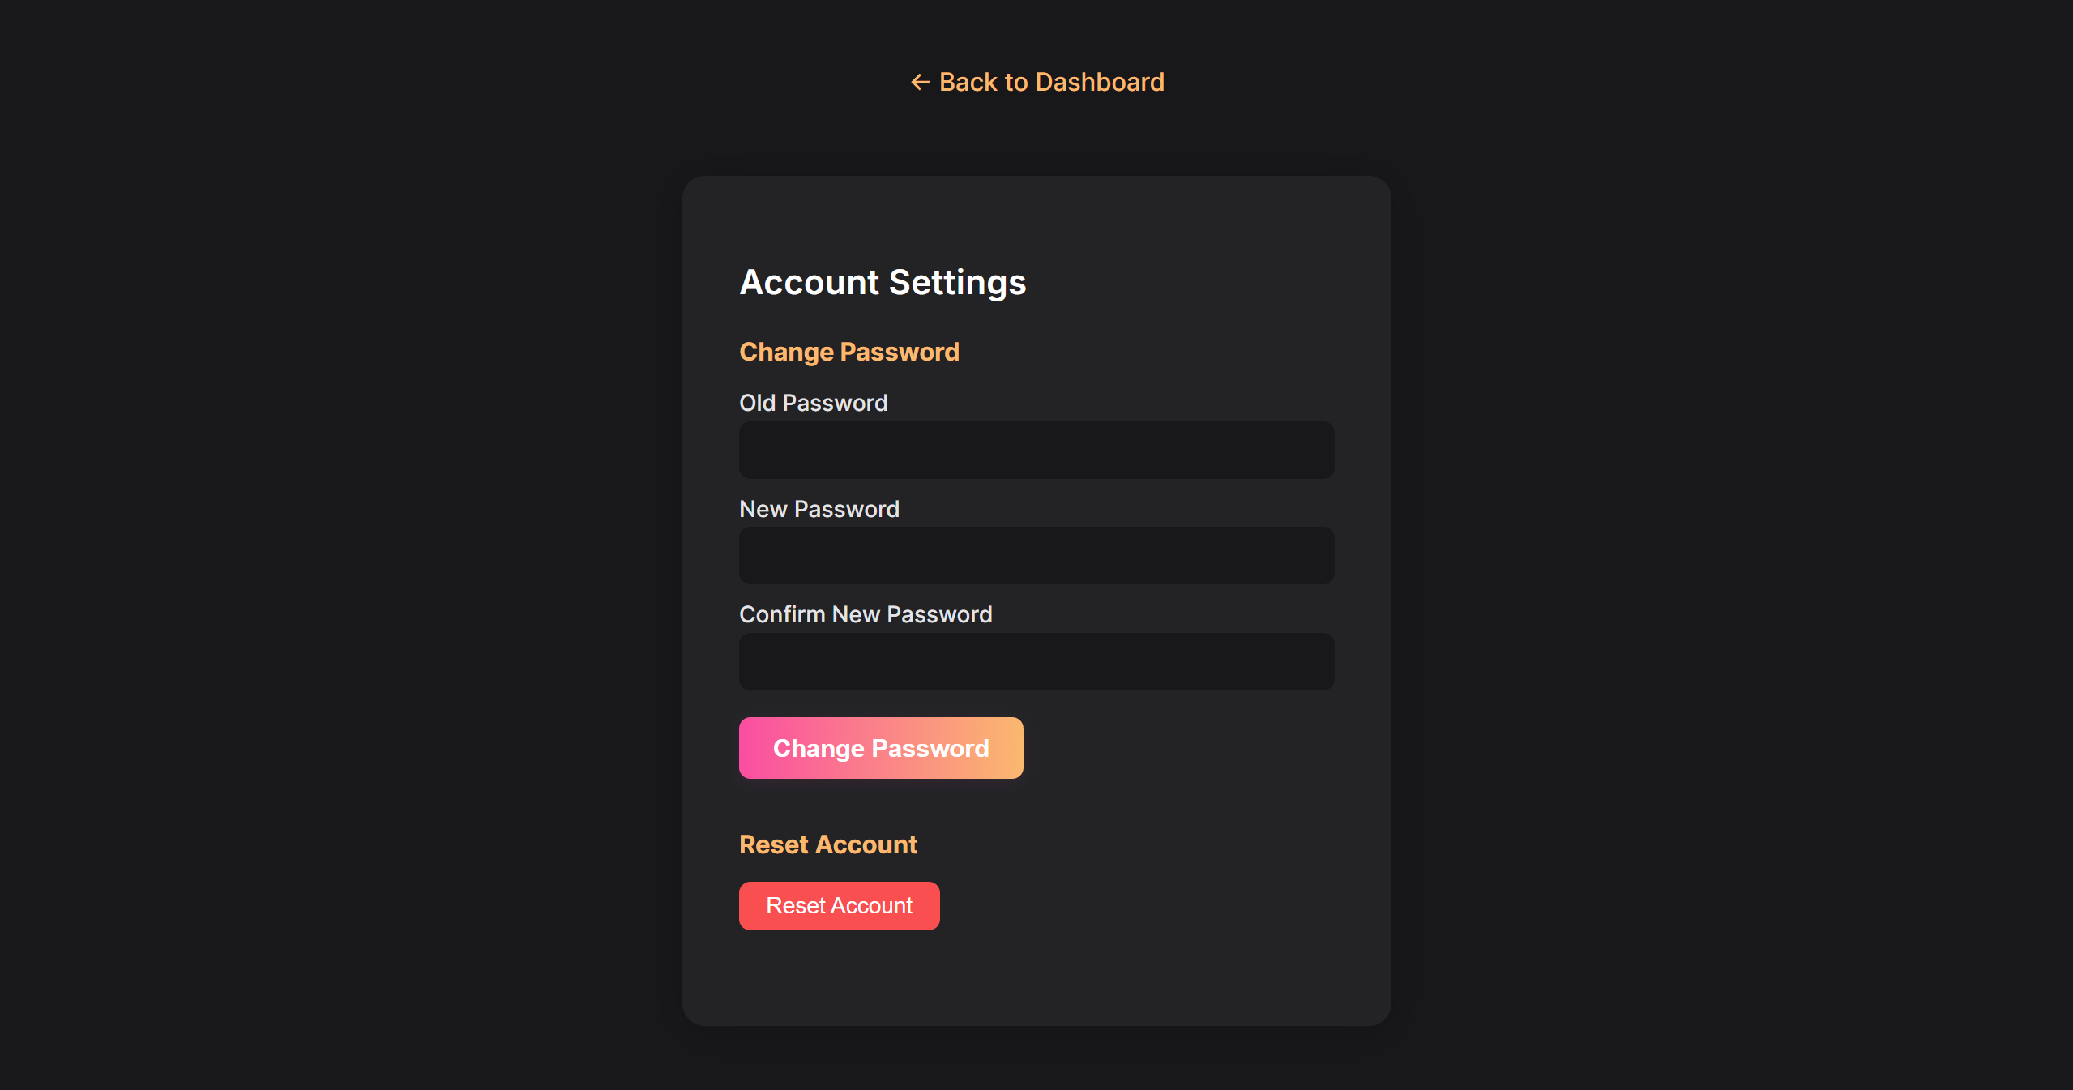

Figure 3.6 Settings Page

**3.2 Committed Vs Completed User stories**

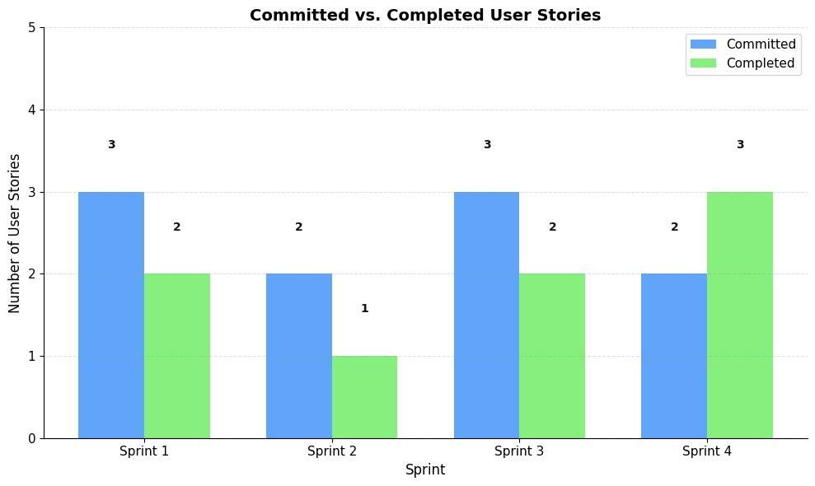

Figure 3.7 Bar graph for Committed Vs Completed User Stories

The project outcomes highlight the user interface and core functionalities developed through the EatFit project. Figure 3.1 presents the Sign-Up Page, where new users can register and begin their journey with the application. Figure 3.2 displays the Login Page, allowing users to securely access their accounts. Figure 3.3 showcases the RaiseUp user dashboard, the user can add challenges and also add pre-requisites to his goals in Figure 3.4. while Figure 3.5 provides the leaderboards section where the user can compete with his friends. Figure 3.6 shows the settings menu where the user can change his password or reset his/her progress.

In addition, the overall sprint progress is evaluated through Figure 3.6, a Bar Graph for Committed Vs Completed User Stories, which compares the initially committed user stories with those completed.

**CHAPTER 4**

**CONCLUSION & FUTURE ENHANCEMENTS**

**Conclusion**

RaiseUp demonstrates how fundamental  web technologies can be effectively utilized to create a meaningful impact on personal development and habit formation. Through two focused sprints, the project evolved from a basic authentication system with gamification elements to a comprehensive platform featuring social engagement and offline accessibility. he first sprint established the foundation with secure user registration and an engaging badge system that rewards consistent habit maintenance, while the second sprint enhanced user engagement through community leaderboards and ensured uninterrupted progress tracking with offline capabilities. The application's straightforward approach, built using Python, HTML/CSS, and minimal JavaScript, proves that effective solutions don't require complex frameworks to achieve their goals.

**Future Enhancements**

The Raise Up habit tracking application successfully demonstrates how fundamental web technologies can be effectively utilized to create a meaningful impact on personal development and habit formation. Through two focused sprints, the project evolved from a basic authentication system with gamification elements to a comprehensive platform featuring social engagement and offline accessibility. Future enhancements could include a mobile application development, integration with calendar applications, AI-powered habit recommendations, expanded social features for group challenges, and data analytics for deeper progress insights. These additions would further strengthen Raise Up's position as a comprehensive habit development platform while maintaining its core principle of simplicity and effectiveness.

**APPENDIX**

**A. SAMPLE CODING**

